1)  Create user with name Techie and provide sudo access to user.

sudo adduser techiehorizon

sudo usermod -aG sudo techiehorizon

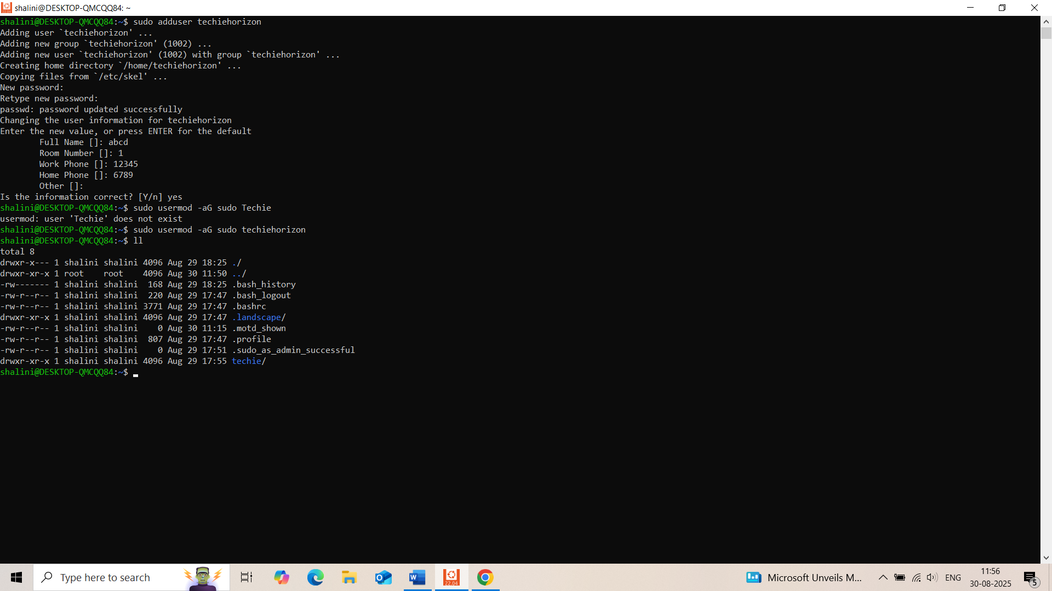

2)  Navigate to the home directory.

cd ~



3)  Create a new directory.

Mkdir mydirectory

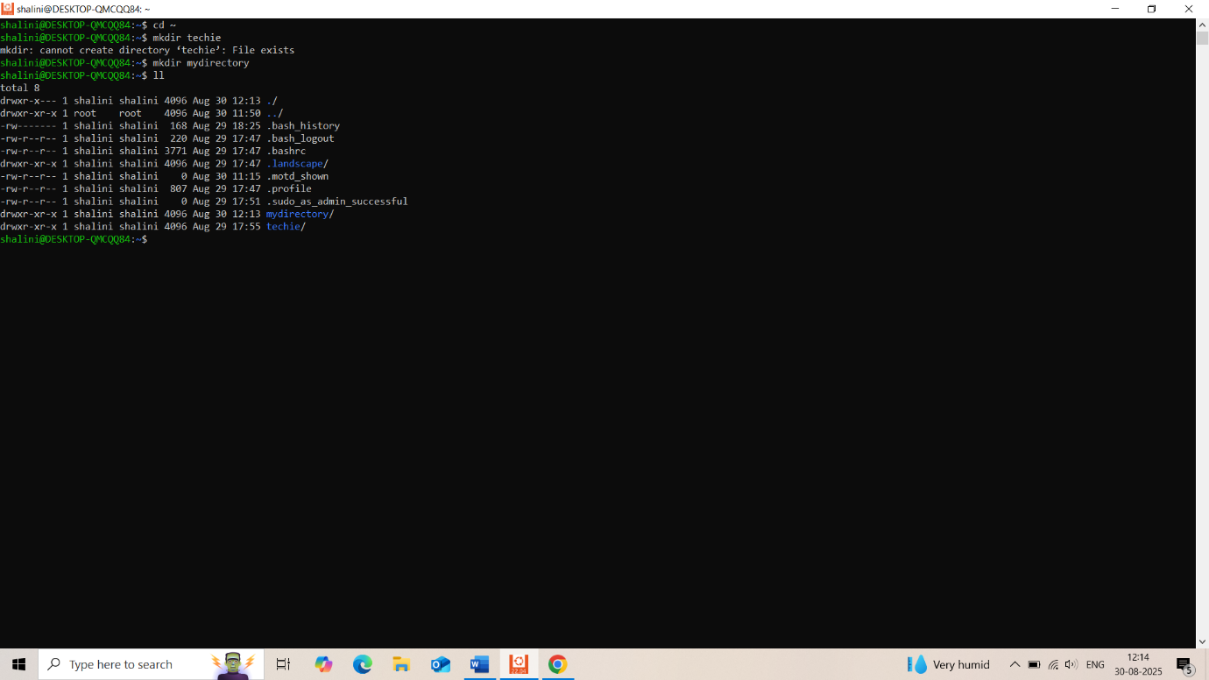

4)  List the contents of a directory.

ls -l

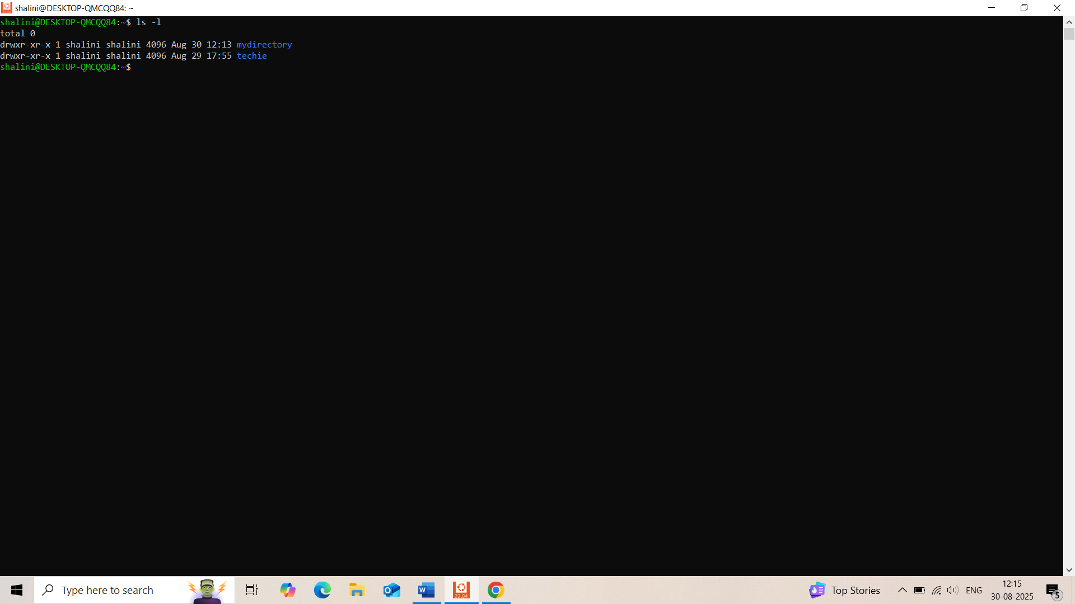  
5)  Change the current directory.

6)  Create a new empty file.

touch filename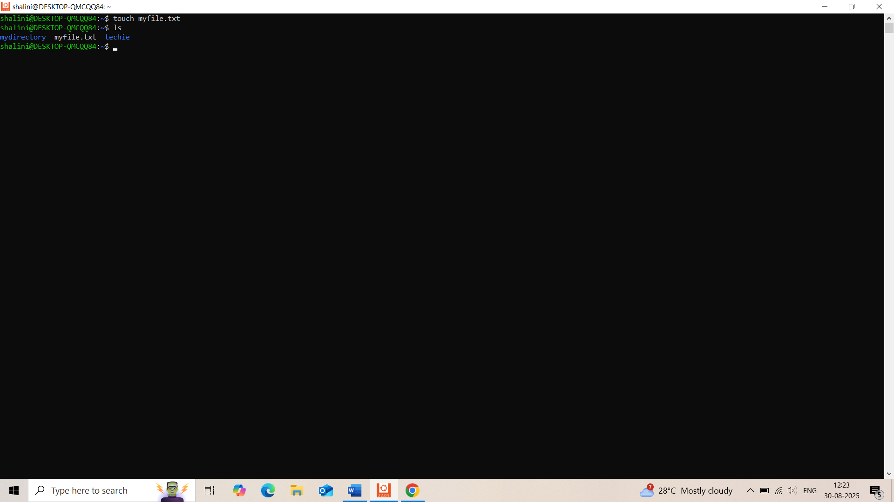  
7)  View the contents of a file.

Cat filename(myfile.txt)

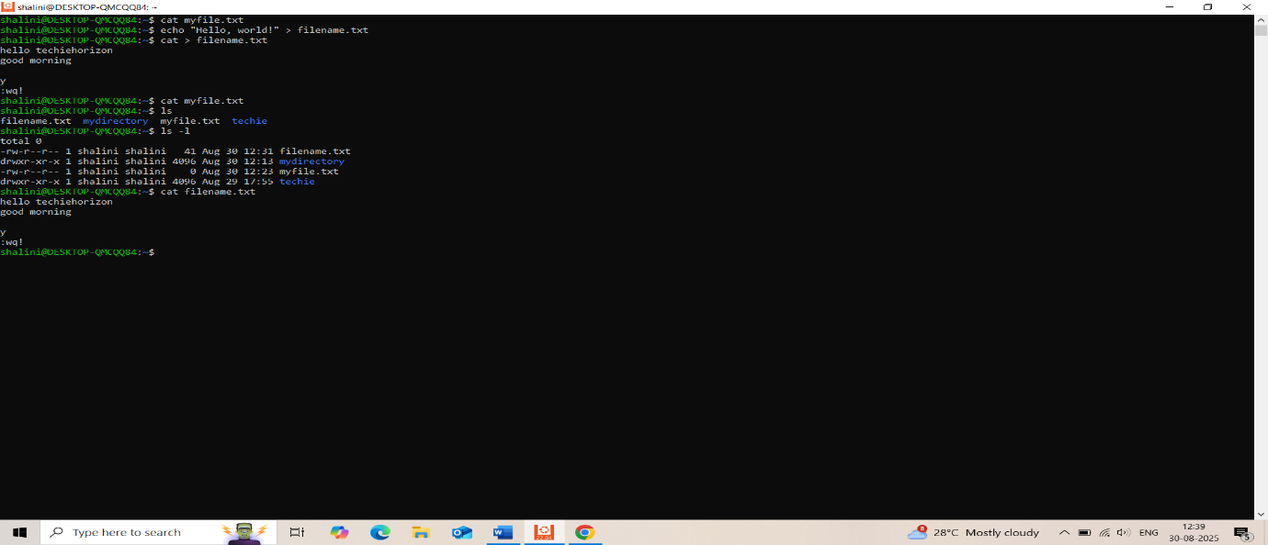  
8)  Copy a file to another location.

cp myfile.txt /path/to/destination/

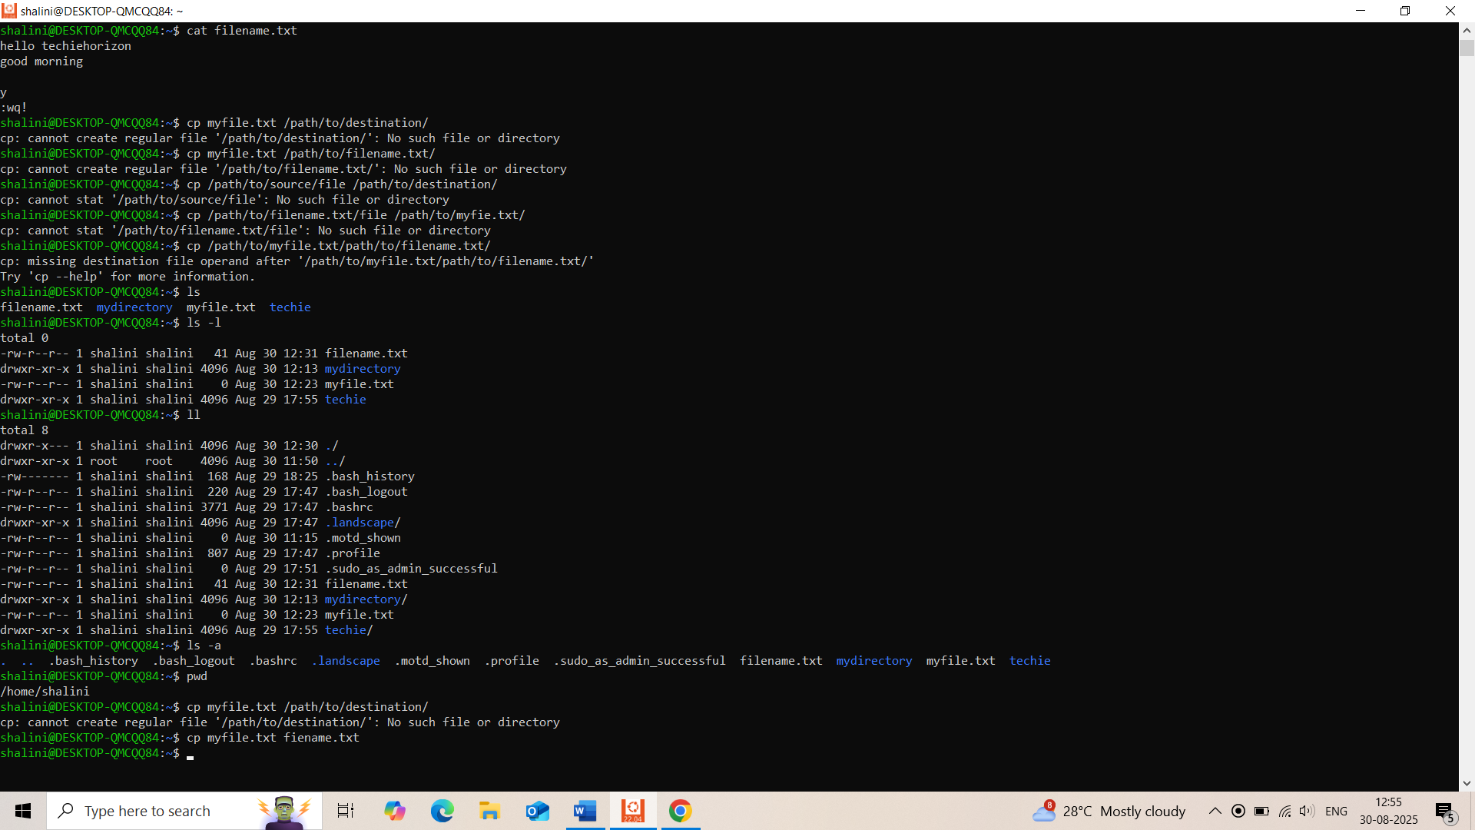  
9)  Move a file to another location

mv myfile.txt filename.txt

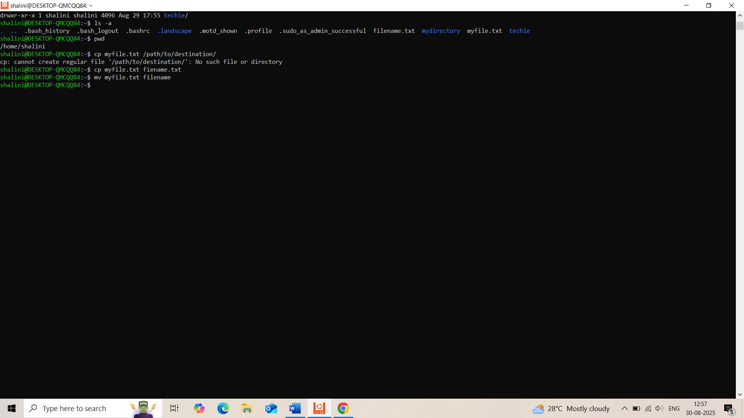  
10) Rename a file

Mv old filename newfilename

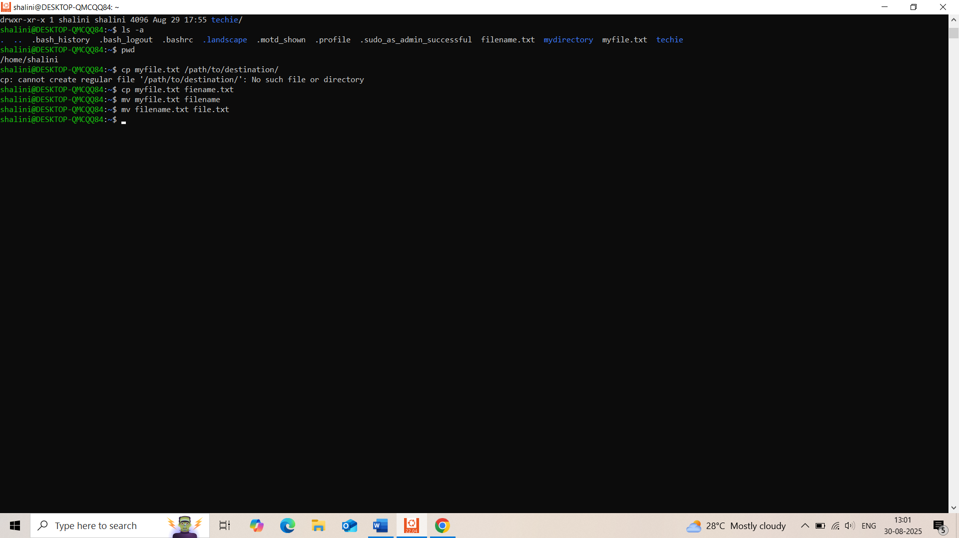

11) Delete a file.

To delete a file we use “rm”

rm filename

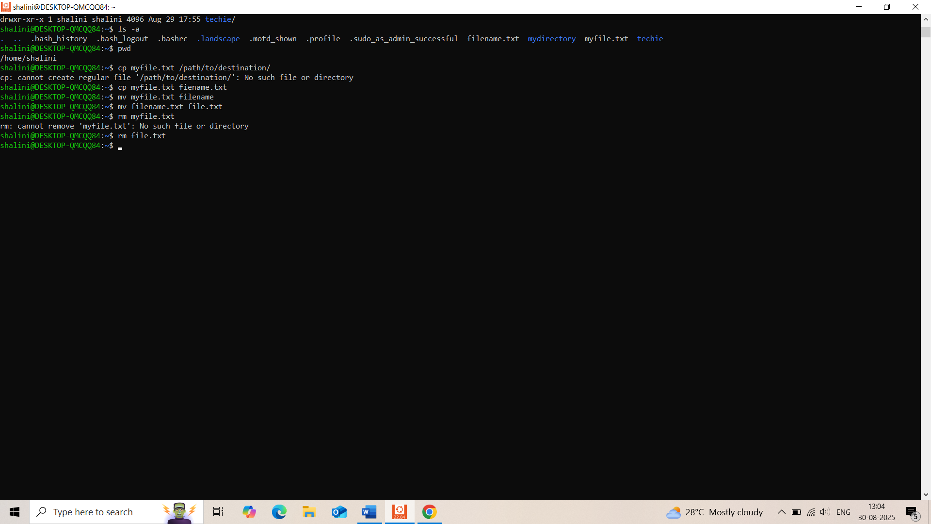

12) Grant or revoke permissions on a file or directory.

To grant file we use chmod 755 filename

To revoke file we use chmod 000 filename

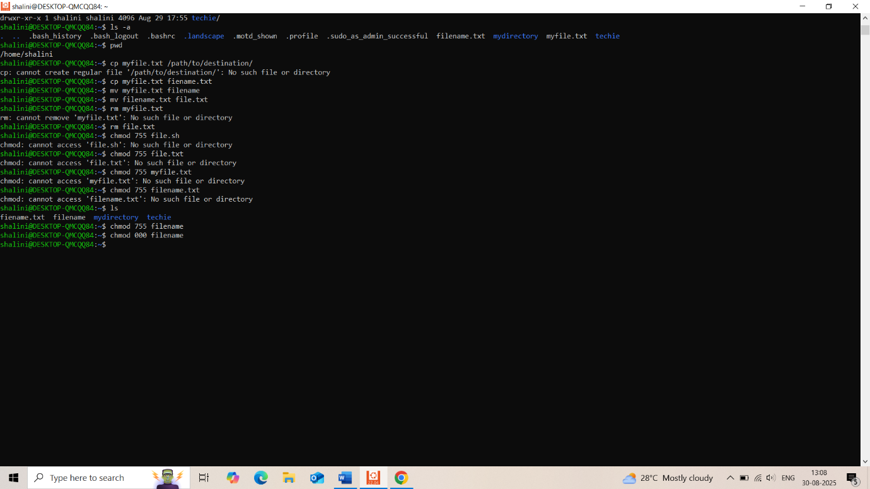

13) View the current date and time.

To view the current date and time wu use the command “date”

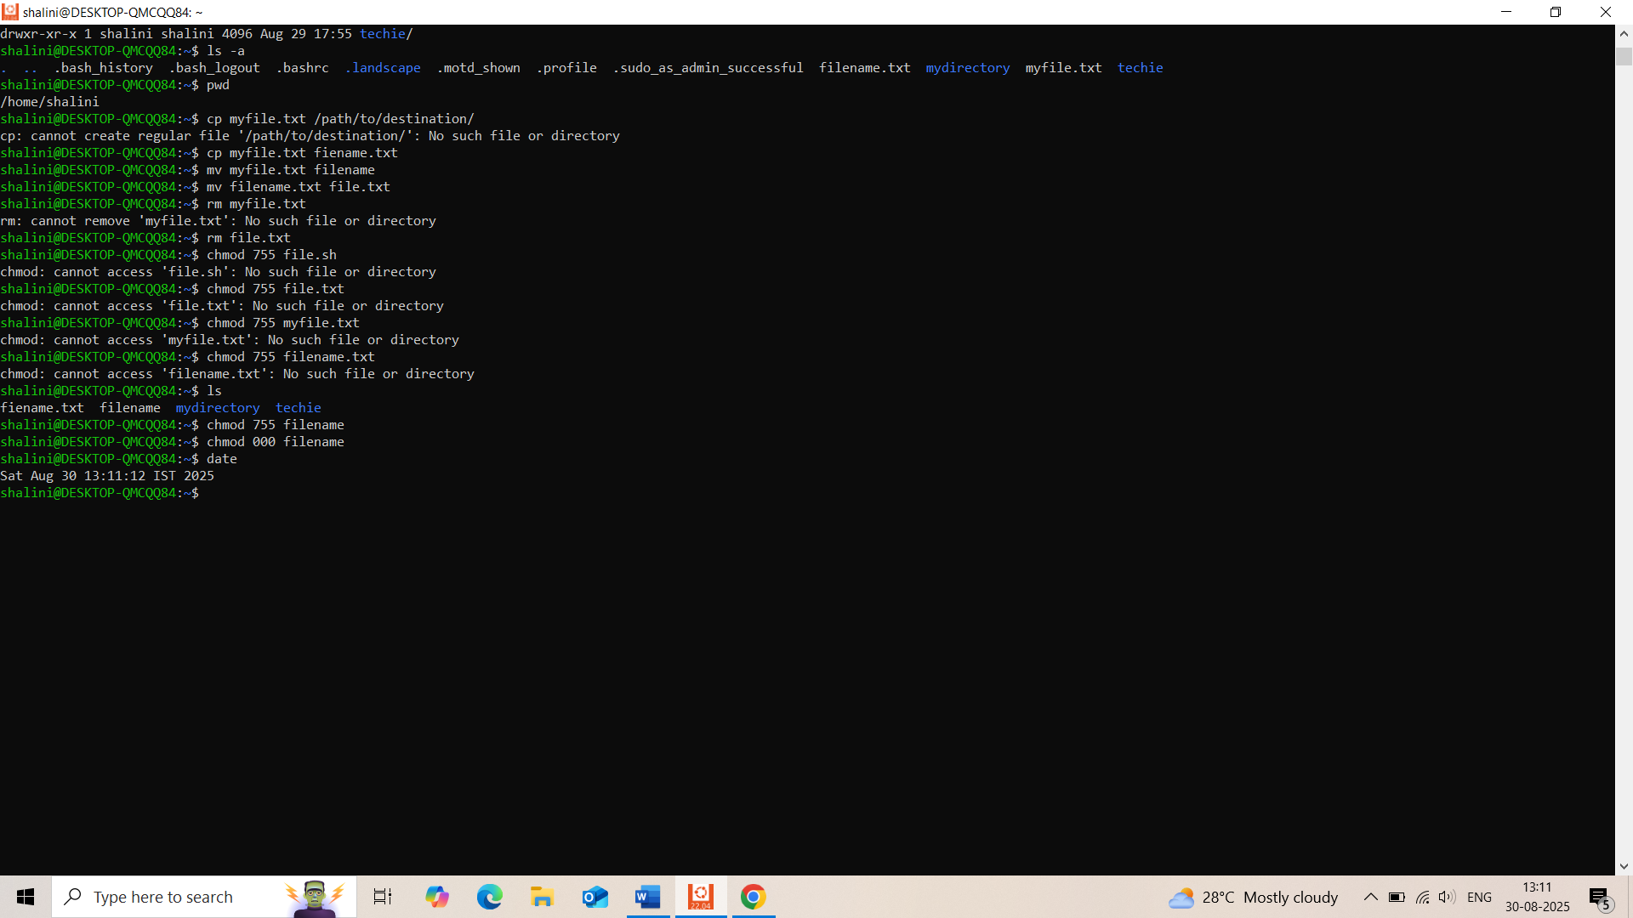

14) Check the system uptime.

To view the uptime we use the command “uptime”

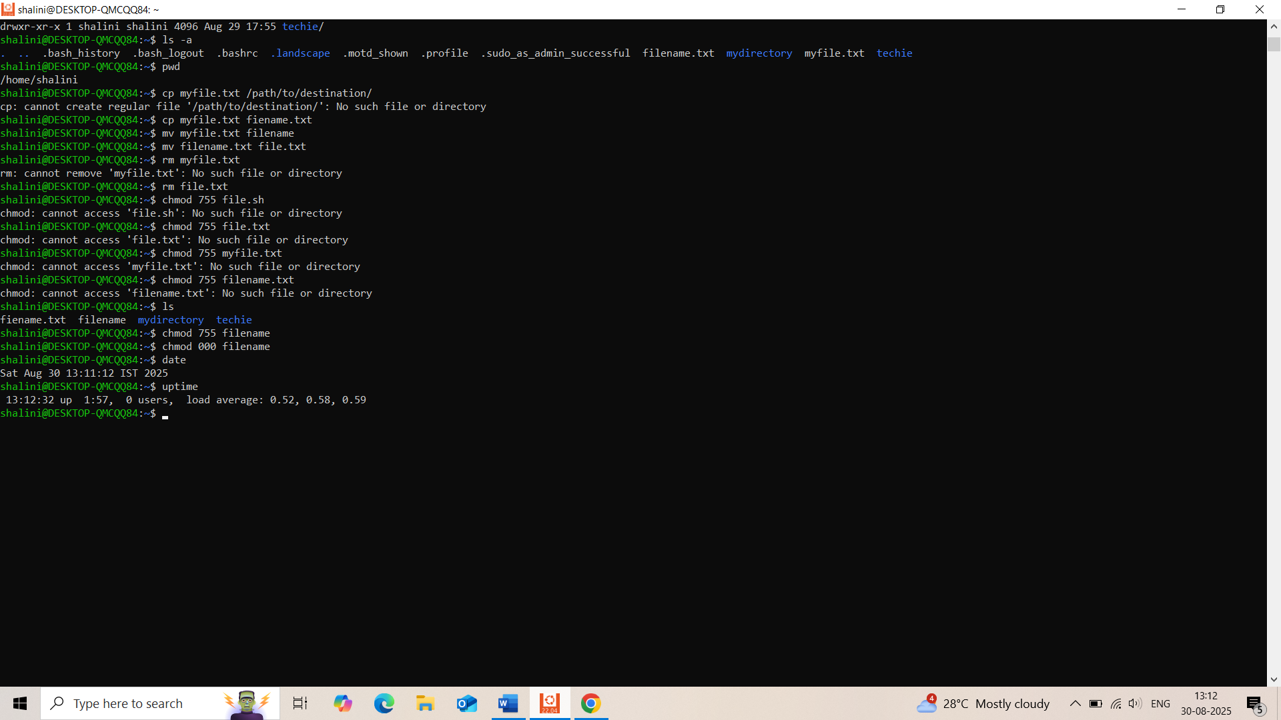

15) View the running processes.

To view the running process we use the command “ps aux”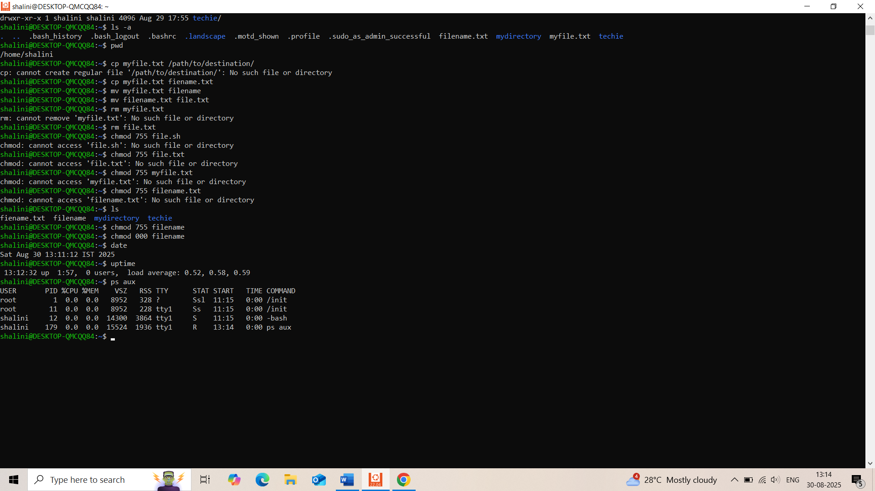

16) Kill a running process.

To kill a process we use command “kill -9 processidy”

17) Install a package using the package manager (e.g., apt or yum).

A:The command used to install a package using oackage manager “sudo apt install nginx”

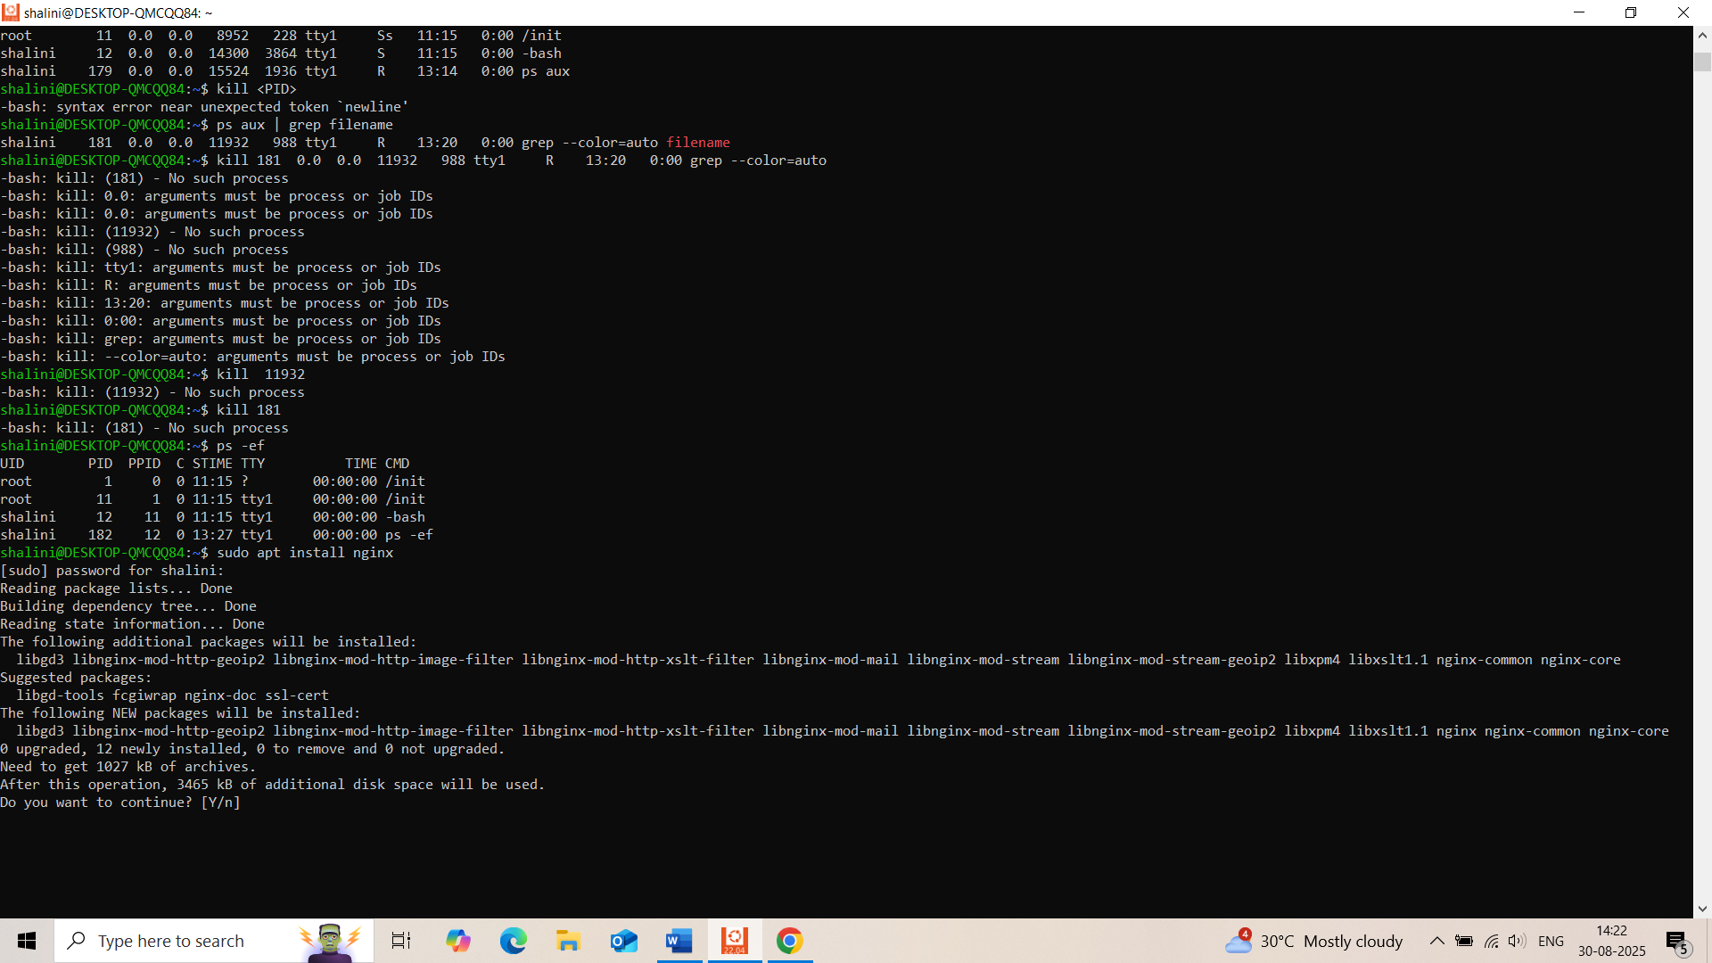

18) Update the system packages.

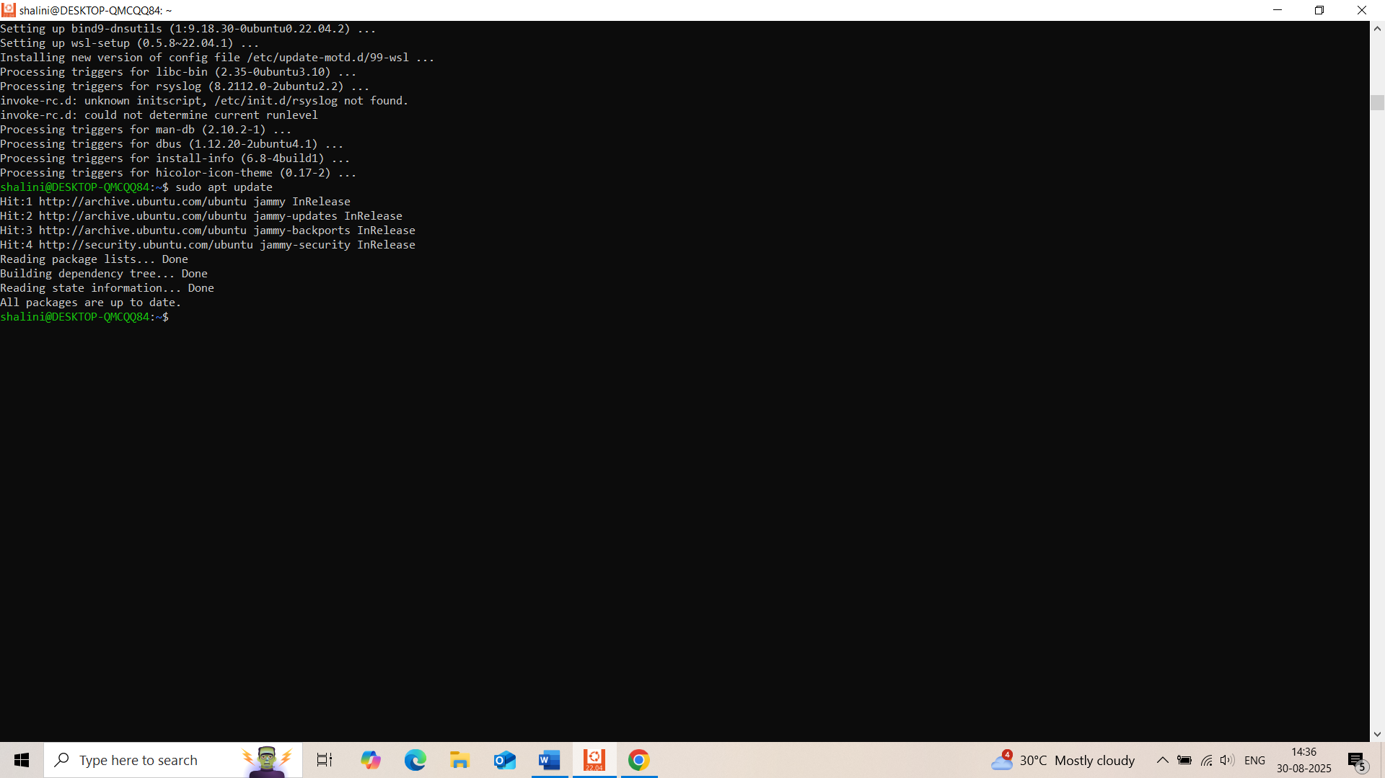

19) Create a symbolic link.

The ln command is used to create links in Linux. When you want to create a symbolic link, you use the -s option with ln. “ ln -s “

ln -s /path/to/original/file /path/to/symlink

/path/to/original/file: The full path to the file or directory you want to link to.

/path/to/symlink: The path and name of the symbolic link you want to create.

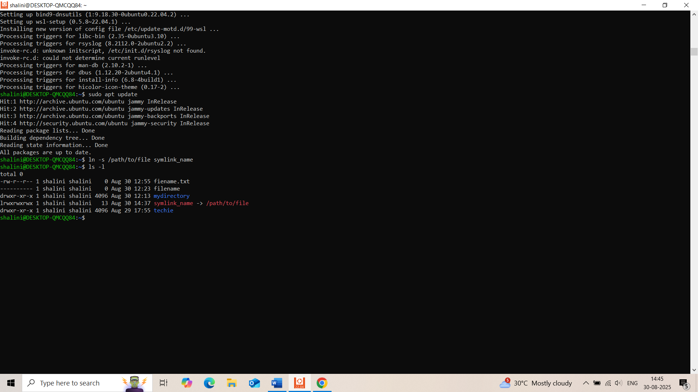

20) Search for files using the find command.

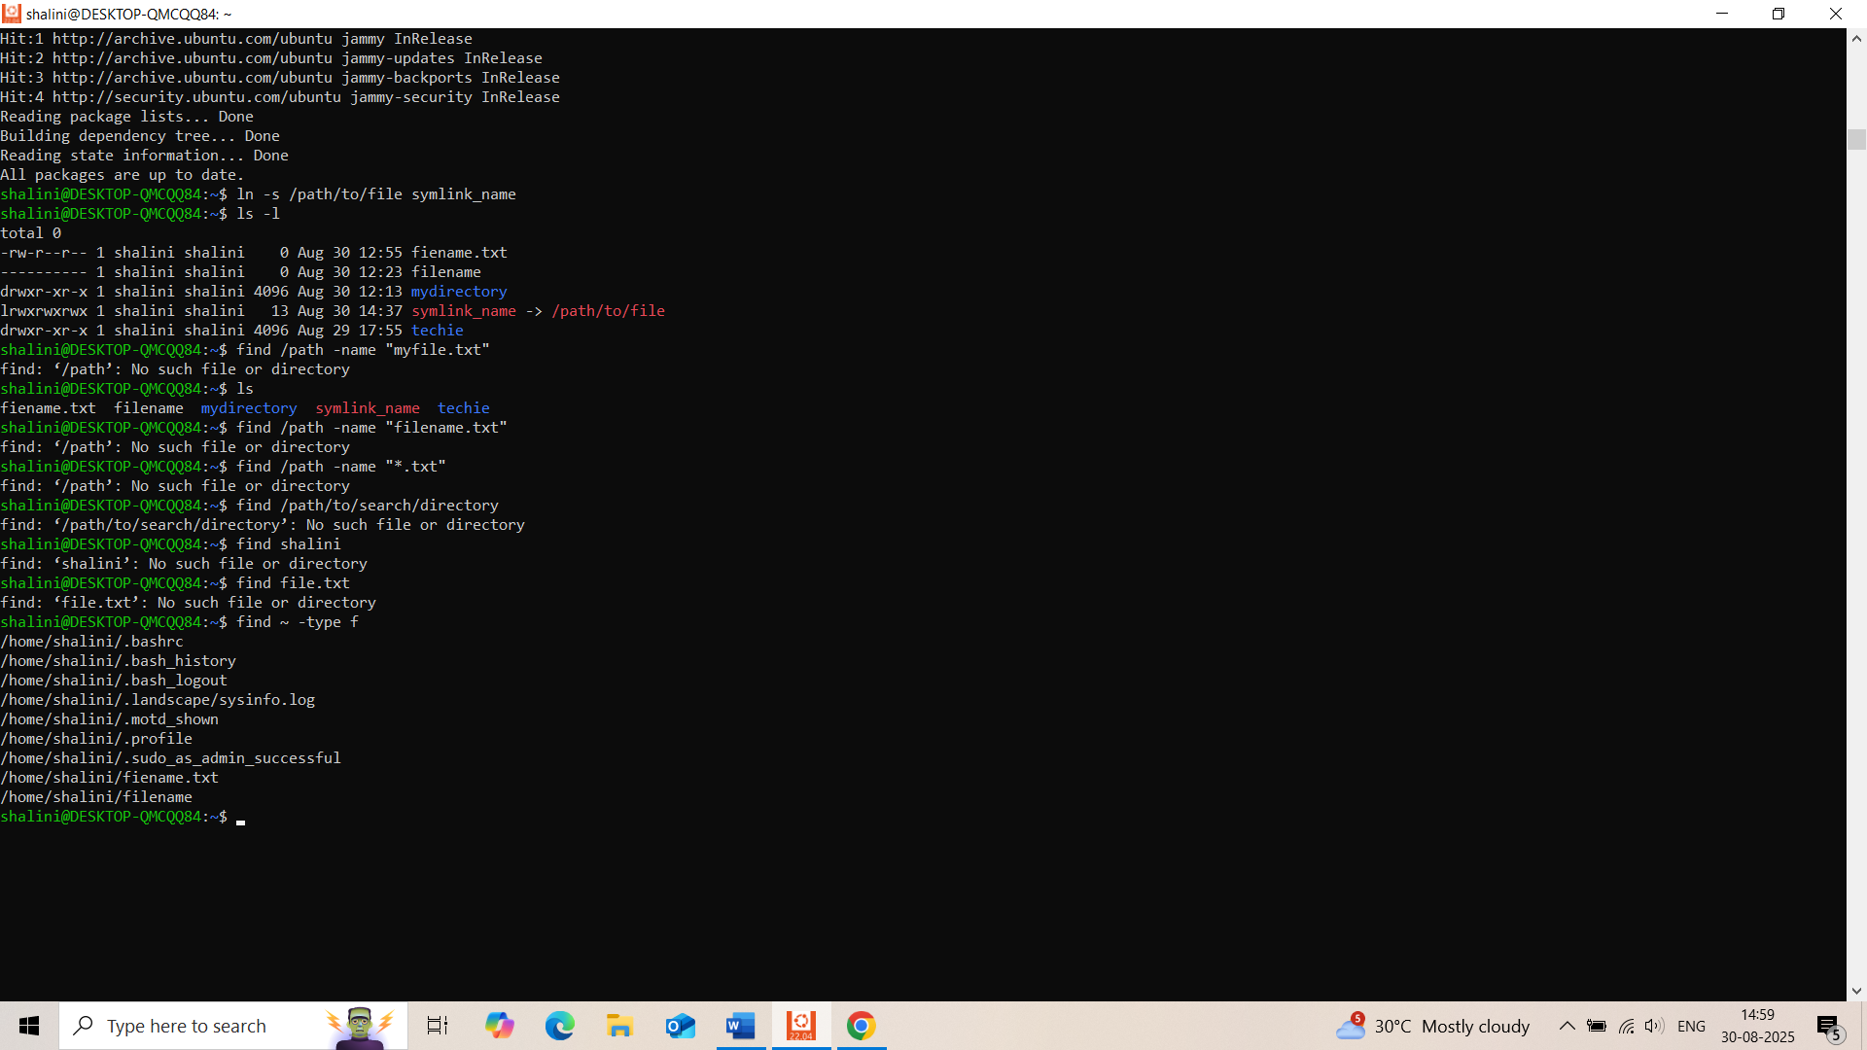

21) Compress and decompress files using tar.

# To Compress

tar -czvf archive.tar.gz folder/

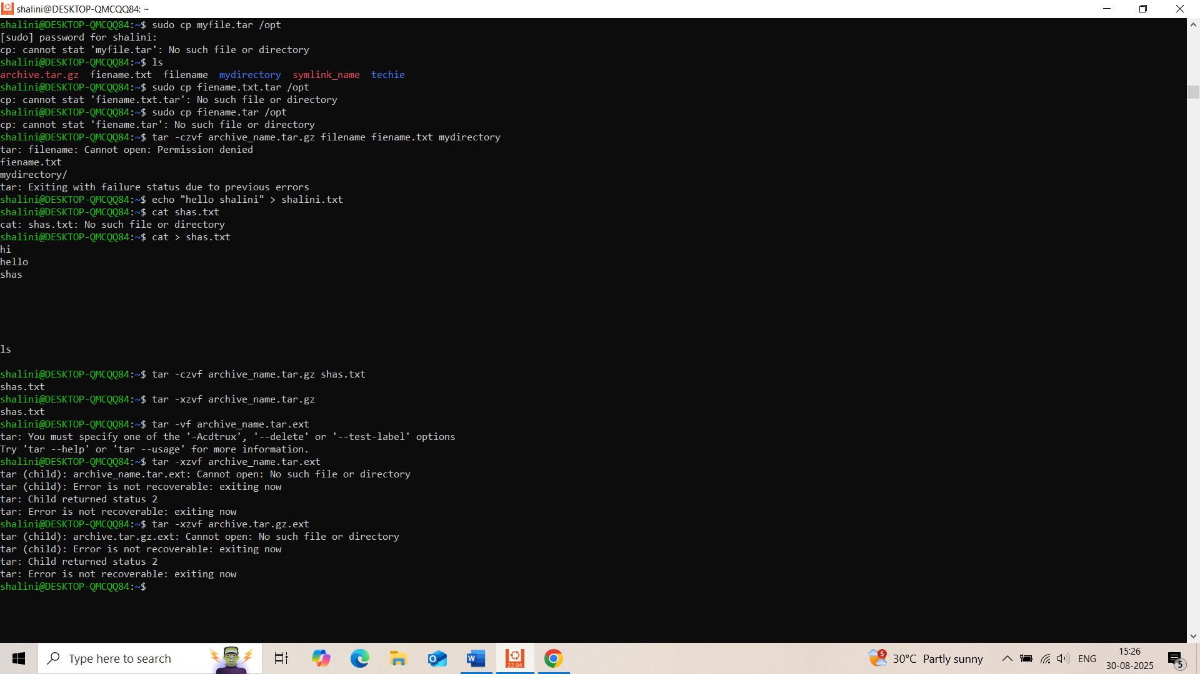

# To Decompresstar -xzvf archive.tar.gz

22) Monitor system resources with top or htop.

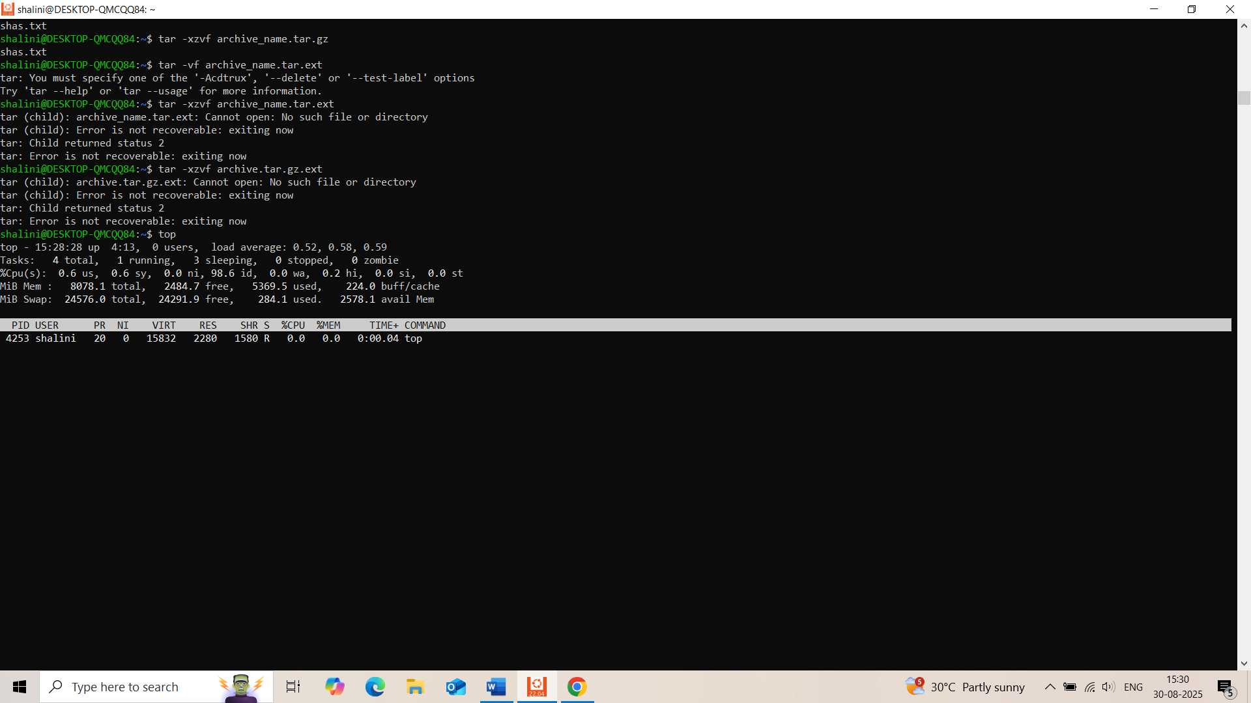

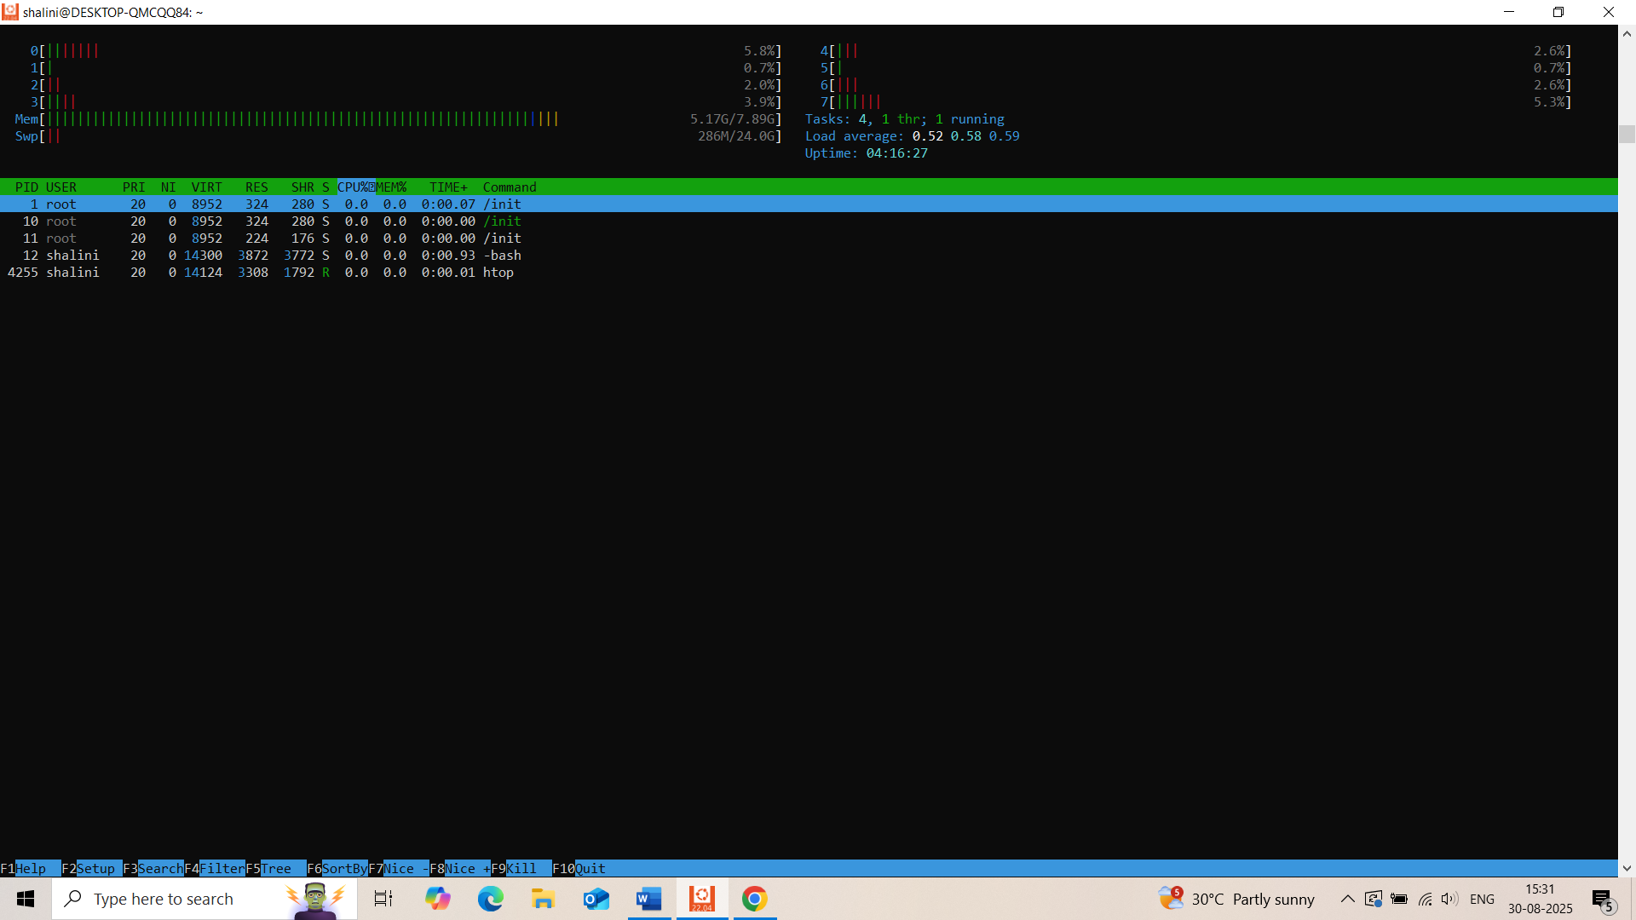

23) Create and manage user groups.

sudo groupadd devs

sudo usermod -aG devs Techie

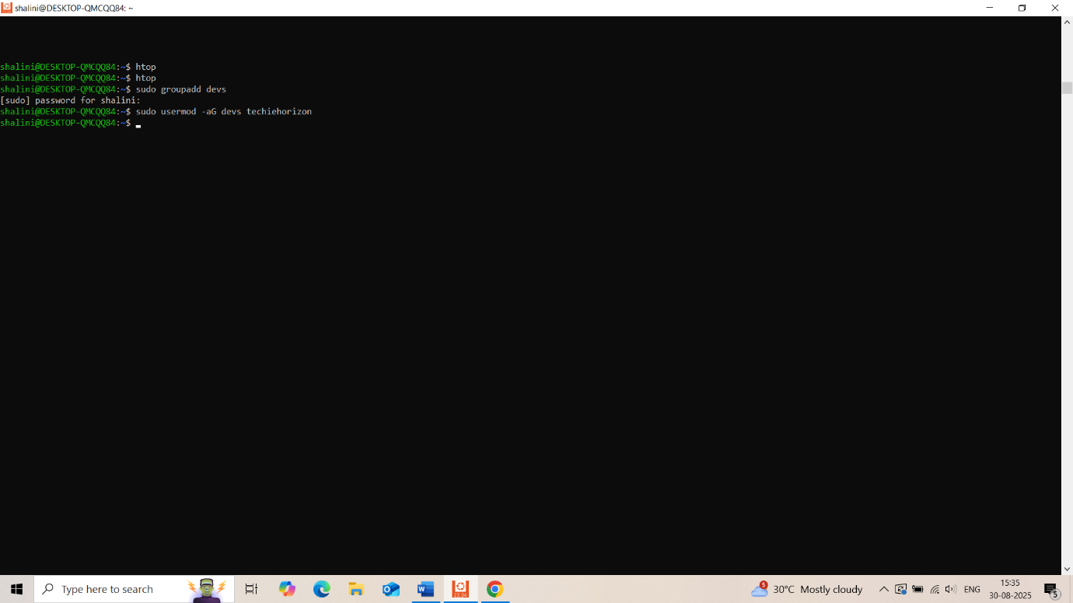

24) Set up SSH password less authentication.

# On client

ssh-keygen

ssh-copy-id user@remote_host

25) Monitor log files using tail or grep.

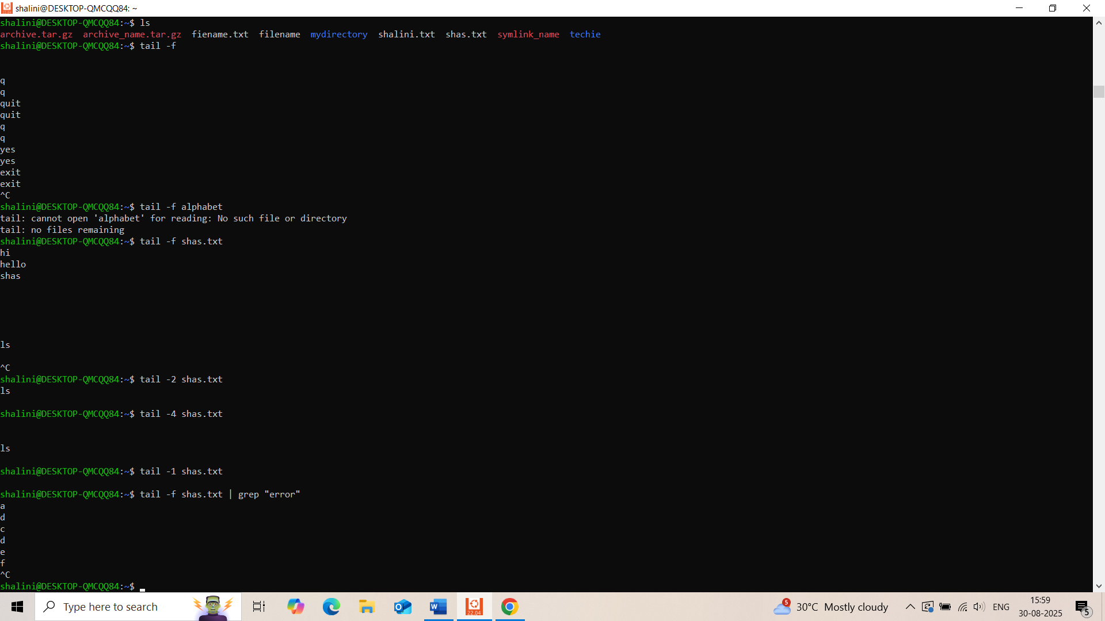

26) Set up a web server (e.g., Apache or Nginx).

sudo apt install apache2 # or nginx

sudo systemctl start apache2

sudo systemctl enable apache2

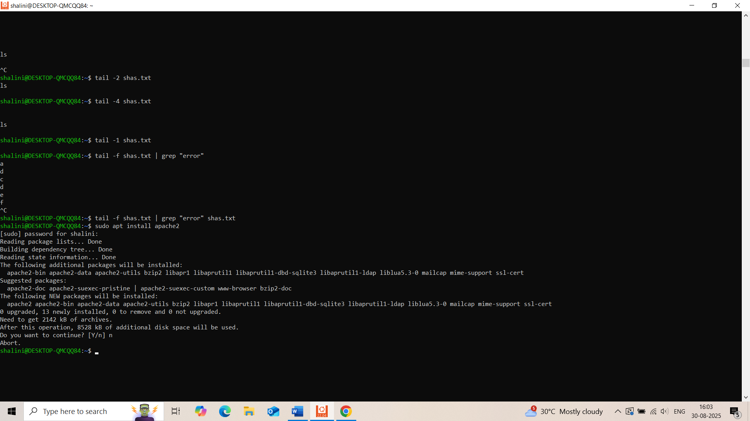

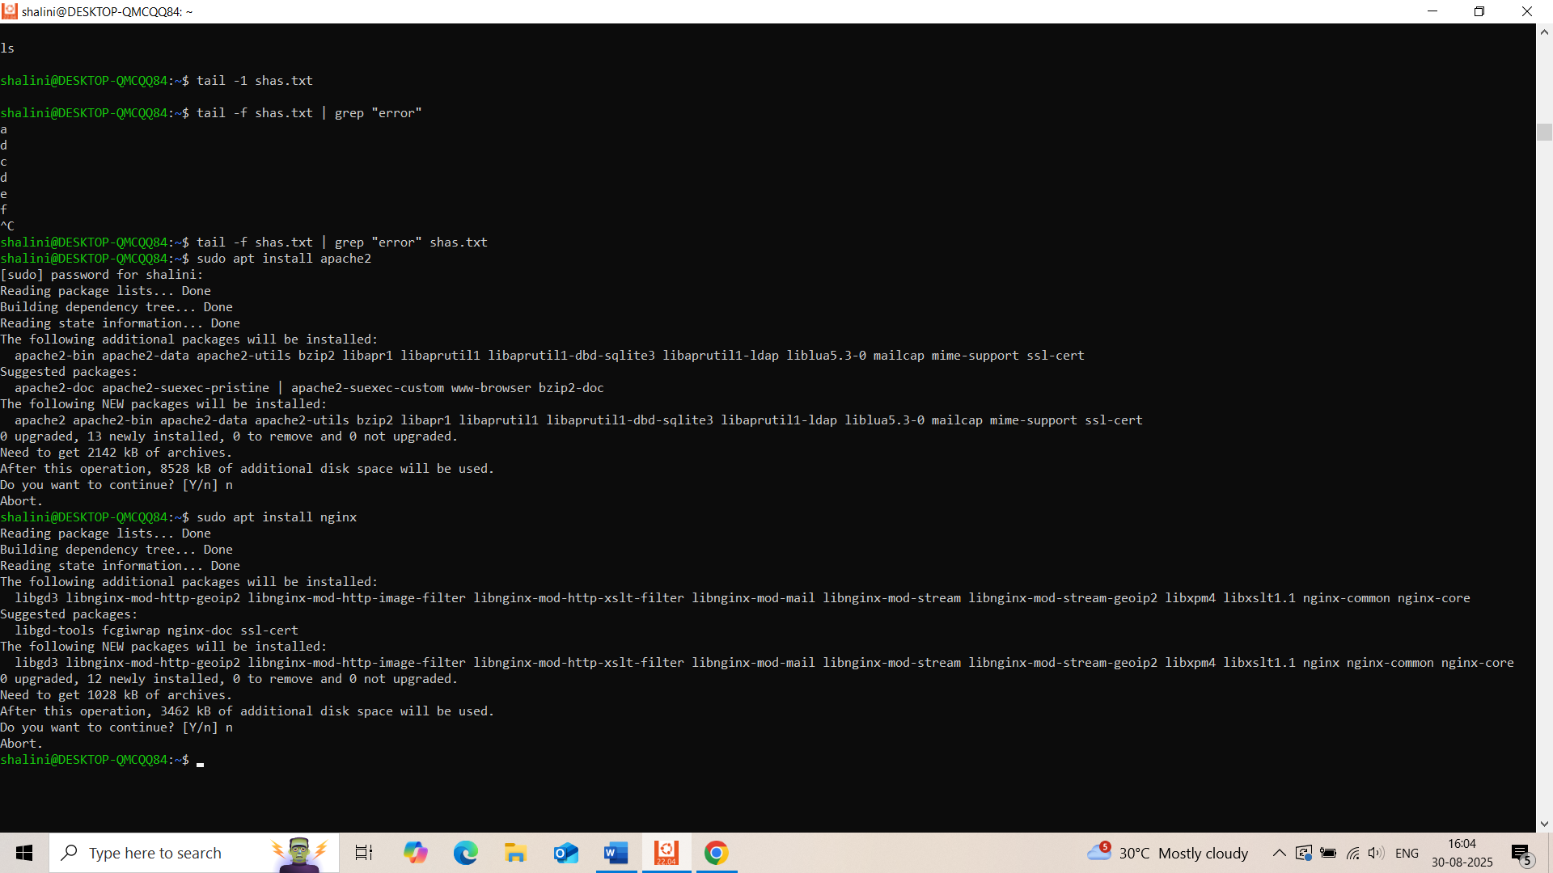

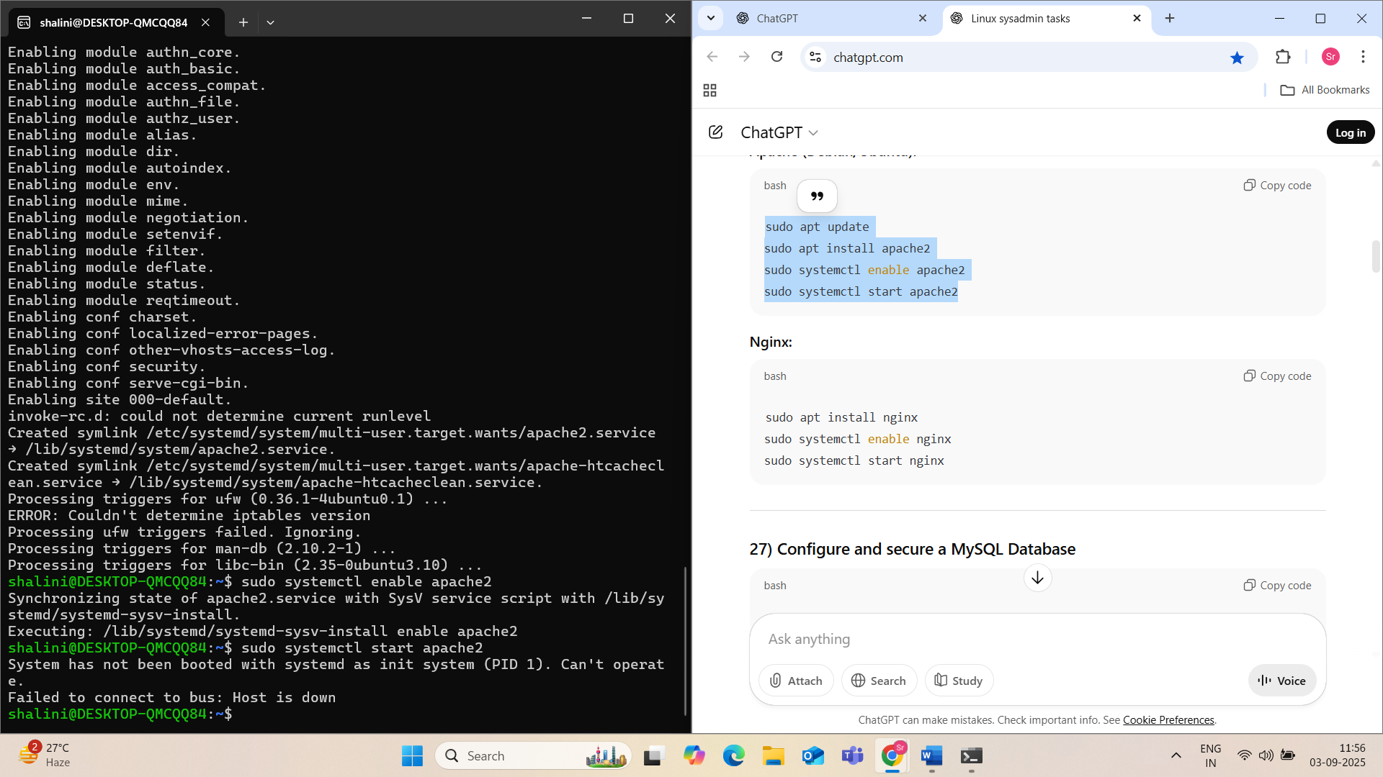

27) Configure and secure a MySQL Database.

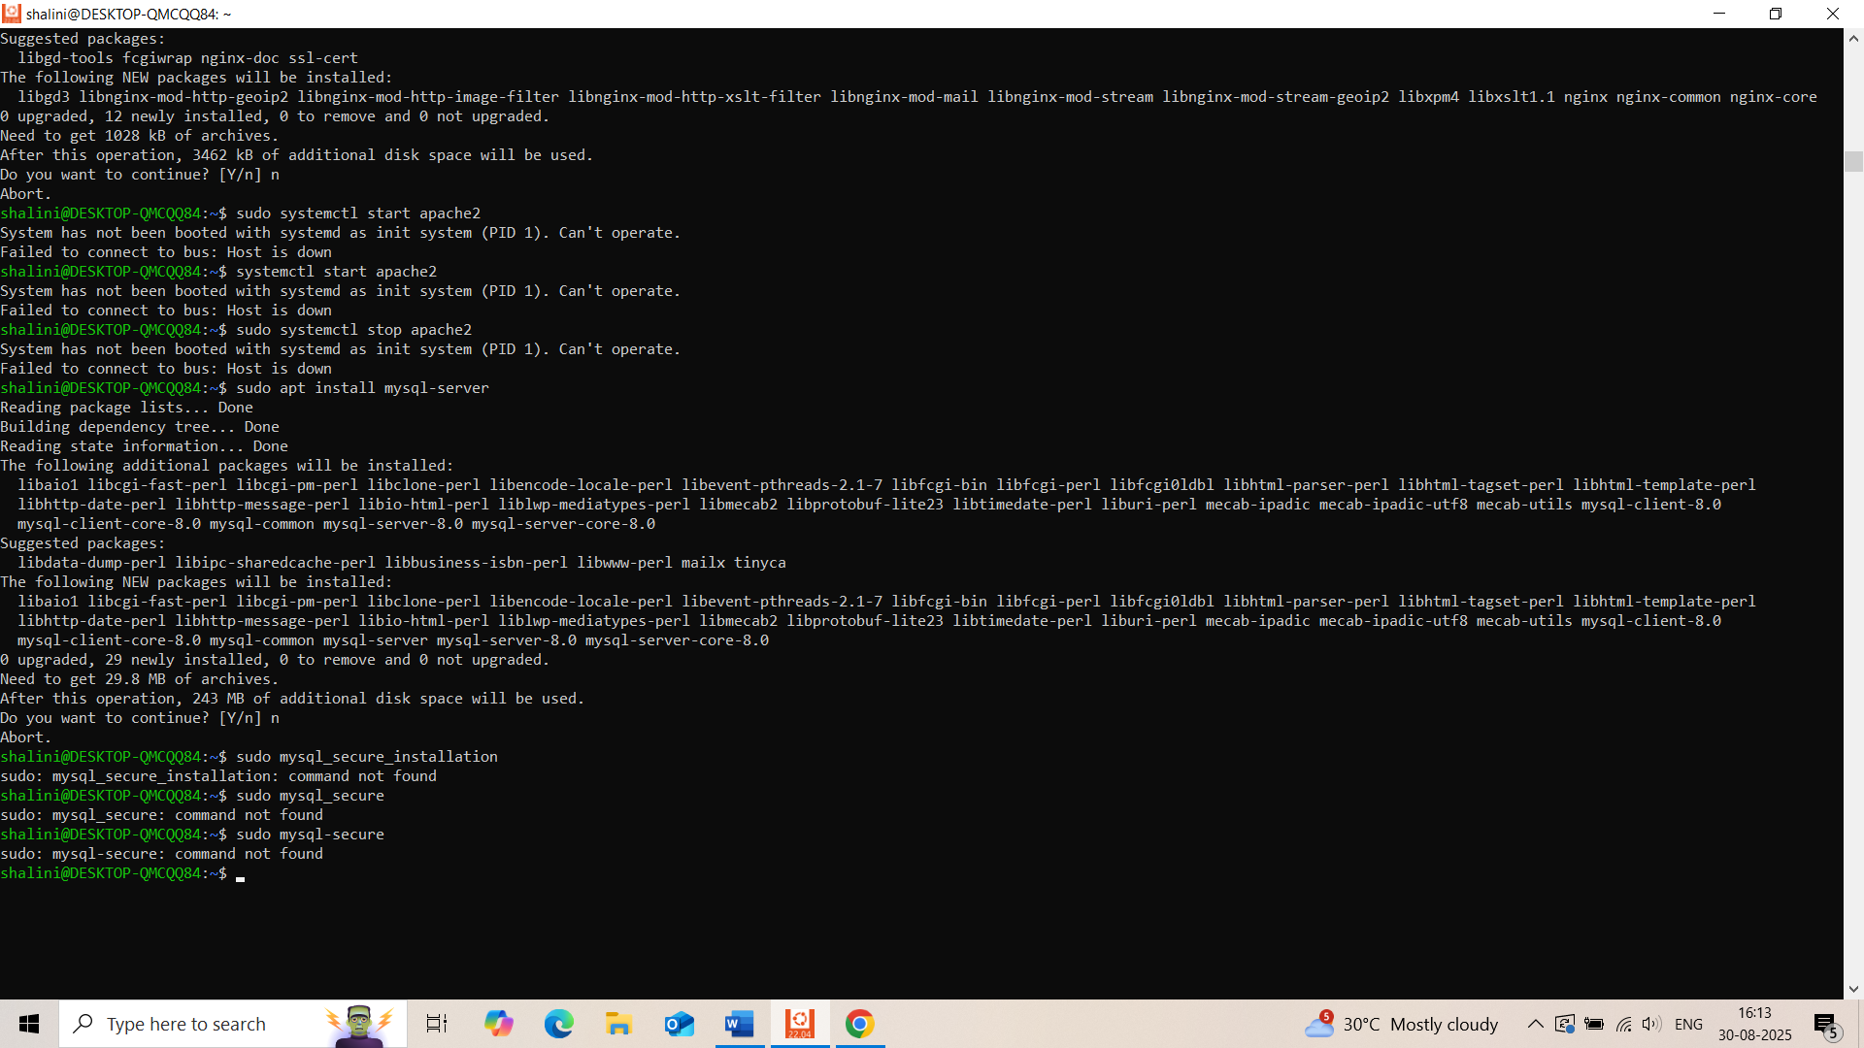

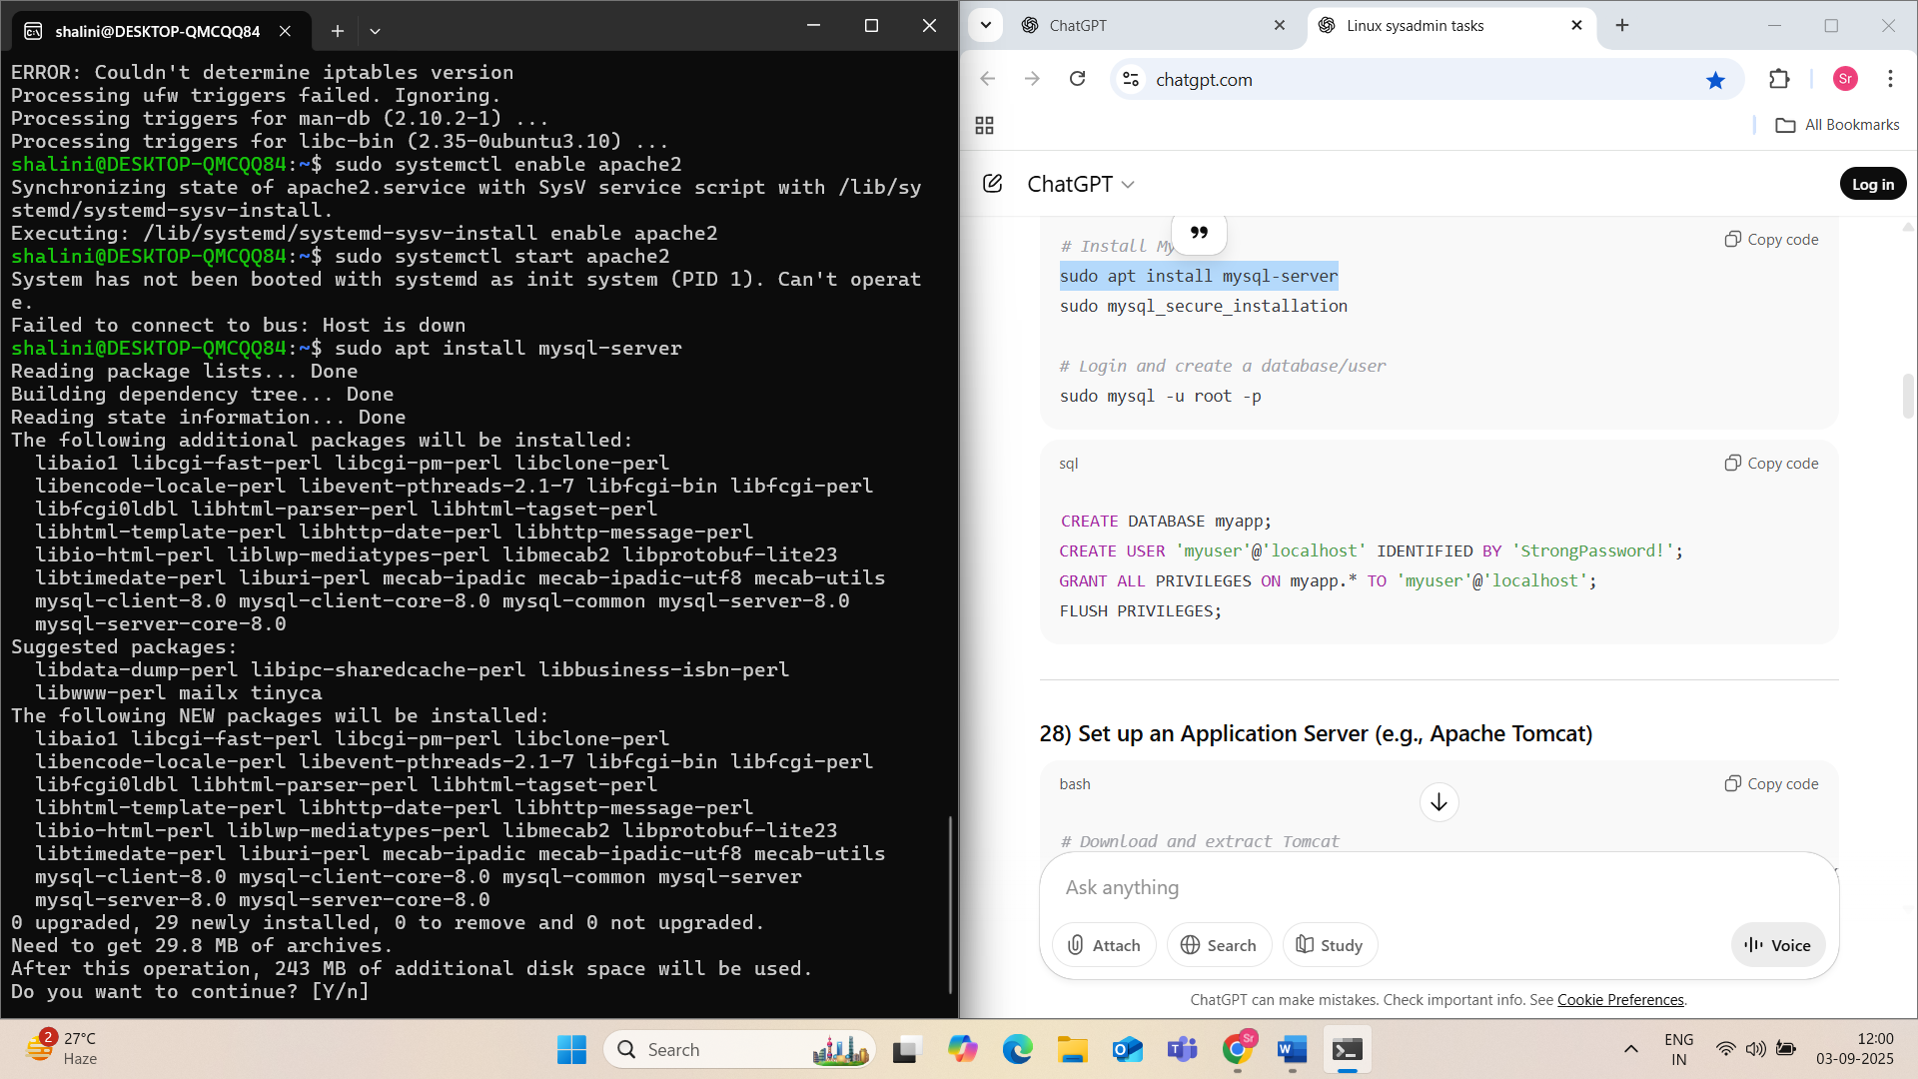

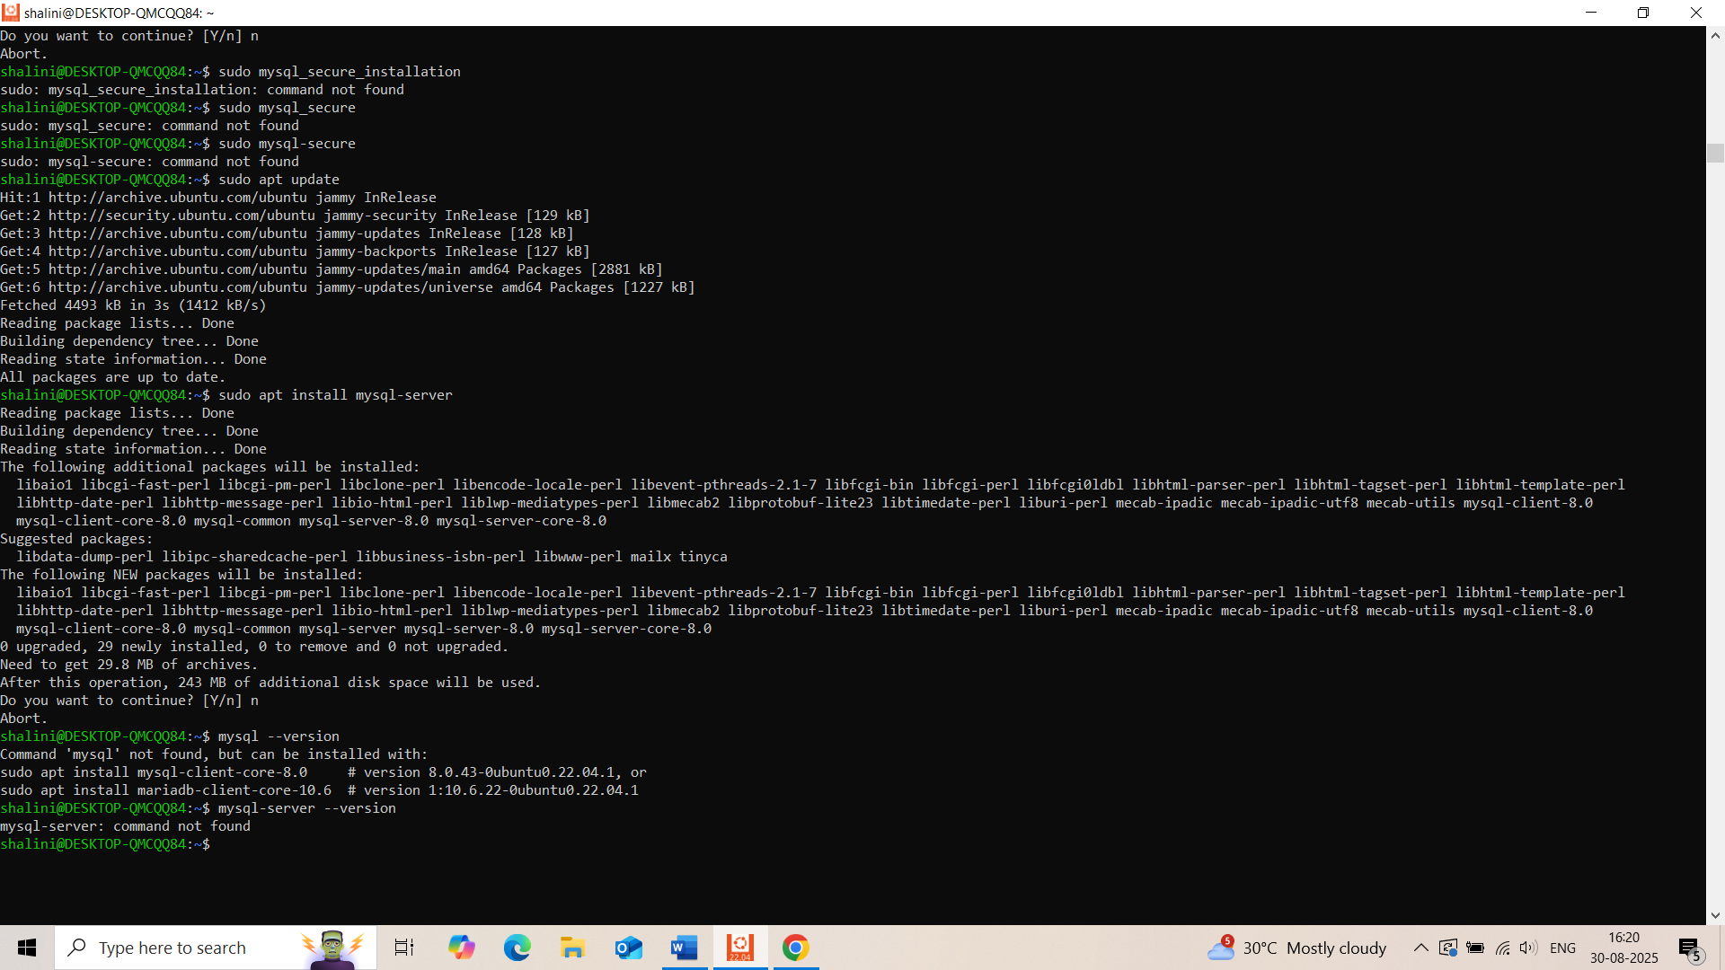

28) Set up a Application Server (e.g.,Apache Tomcat)

sudo apt update

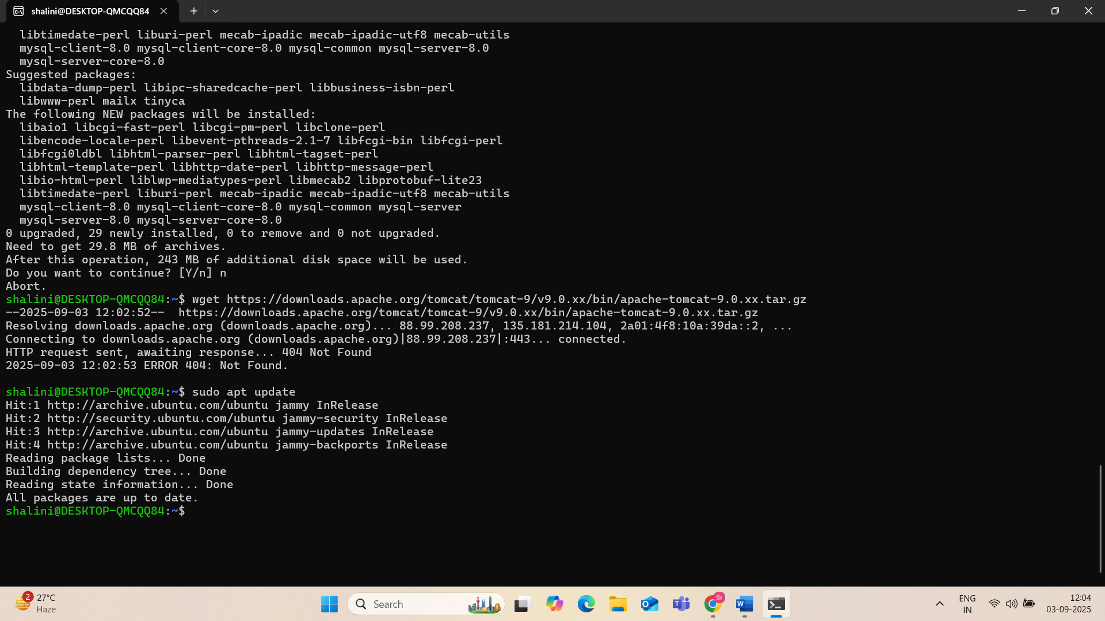

sudo apt install default-jdk -y

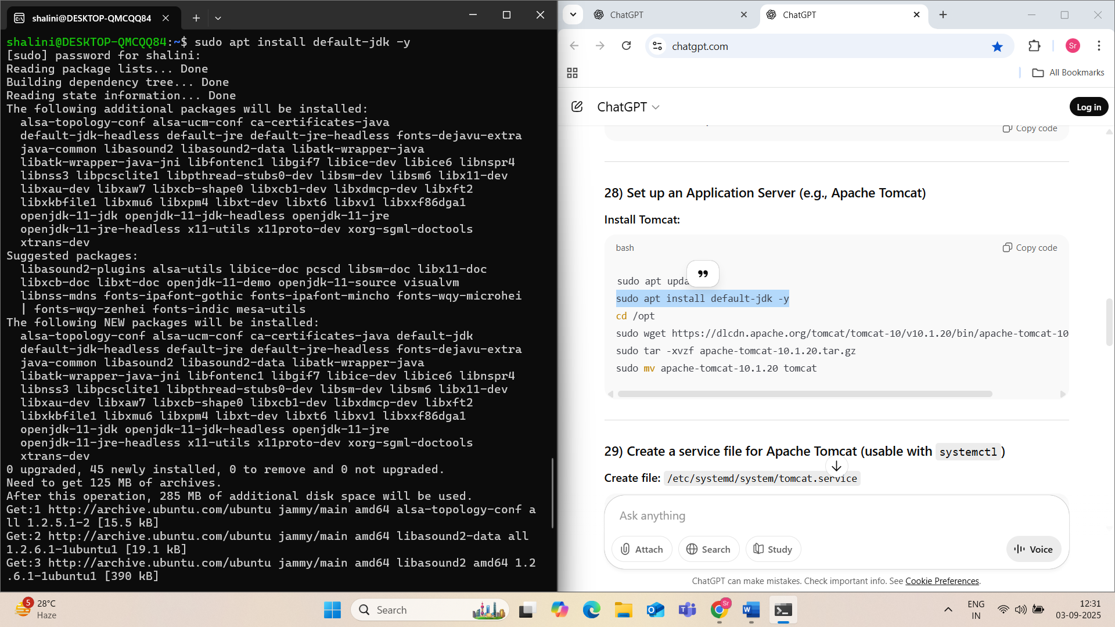

cd /opt

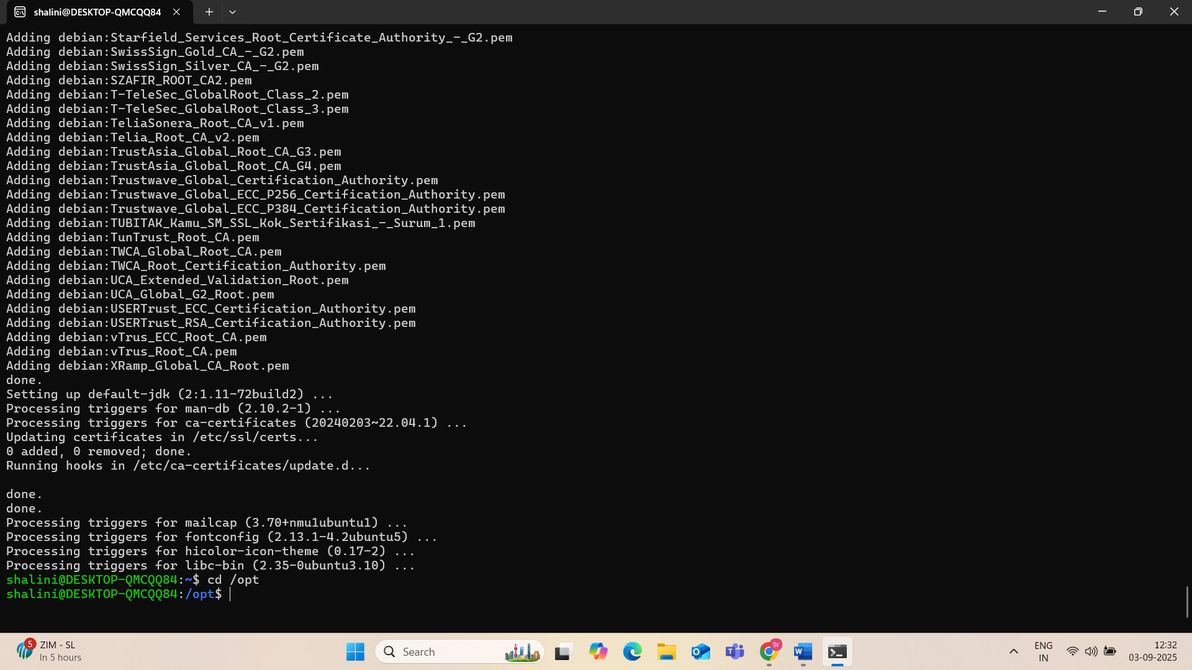

sudo wget <https://dlcdn.apache.org/tomcat/tomcat-10/v10.1.20/bin/apache-tomcat-10.1.20.tar.gz>

sudo tar -xvzf apache-tomcat-10.1.20.tar.gz

sudo mv apache-tomcat-10.1.20 tomcat

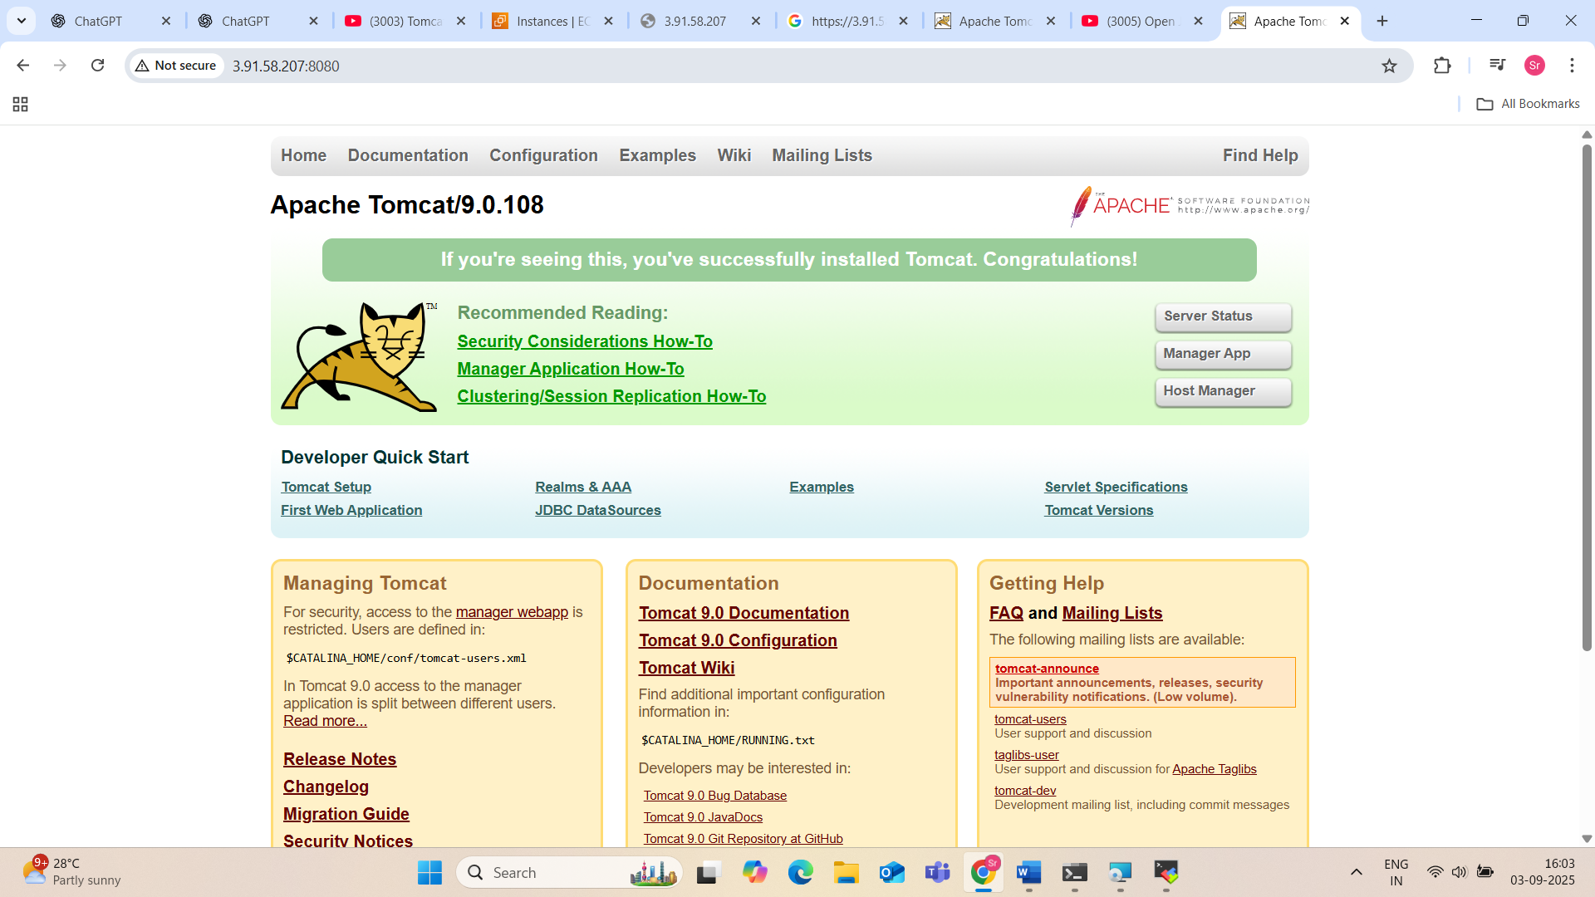

29) create a service file for Apache Tomcat.(Should execute by using systemtctl command)

**Step-by-Step Instructions**

**Step 1: Install Java**

Apache Tomcat requires Java.

# Ubuntu/Debian

sudo apt update

sudo apt install default-jdk -y

Check if Java is installed:

java -version

**Step 2: Create a Tomcat User**

It is good practice to **run Tomcat as a non-root user**.

sudo useradd -r -m -U -d /opt/tomcat -s /bin/false tomcat

Explanation:

* -r: system user
* -m: create home directory
* -U: create user group
* -d /opt/tomcat: home directory
* -s /bin/false: no login shell

**Step 3: Download Apache Tomcat**

Go to the Apache Tomcat download page and get the latest version (e.g., 9.0.82):

cd /tmp

wget https://downloads.apache.org/tomcat/tomcat-9/v9.0.82/bin/apache-tomcat-9.0.82.tar.gz

**Step 4: Extract and Move Tomcat**

sudo mkdir -p /opt/tomcat

sudo tar -xzf apache-tomcat-9.0.82.tar.gz -C /opt/tomcat --strip-components=1

**Step 5: Set Permissions**

sudo chown -R tomcat: /opt/tomcat

sudo chmod +x /opt/tomcat/bin/*.sh

**Step 6: Create the systemd Service File**

Create and open the service file:

sudo nano /etc/systemd/system/tomcat.service

Paste the following content:

[Unit]

Description=Apache Tomcat Web Application Container

After=network.target

[Service]

Type=forking

User=tomcat

Group=tomcat

Environment="JAVA_HOME=/usr/lib/jvm/java-1.8.0-openjdk"

Environment="CATALINA_PID=/opt/tomcat/temp/tomcat.pid"

Environment="CATALINA_HOME=/opt/tomcat"

Environment="CATALINA_BASE=/opt/tomcat"

ExecStart=/opt/tomcat/bin/startup.sh

ExecStop=/opt/tomcat/bin/shutdown.sh

Restart=on-failure

[Install]

WantedBy=multi-user.target

💡 **Check your JAVA_HOME** path:

readlink -f $(which java) | sed "s:bin/java::"

Update the path if necessary.

**Step 7: Reload systemd and Start Tomcat**

sudo systemctl daemon-reload

sudo systemctl start tomcat

To enable Tomcat at boot:

sudo systemctl enable tomcat

To check status:

sudo systemctl status tomcat

**✅ Step 8: Access Tomcat in Browser**

If Tomcat is running on default port **8080**, open your browser and go to:

http://<your-server-ip>:8080

If using EC2, make sure port 8080 is allowed in your **security group**.

30sudo systemctl enable tomcat.

31) Filter and print lines based on a specific pattern or condition.

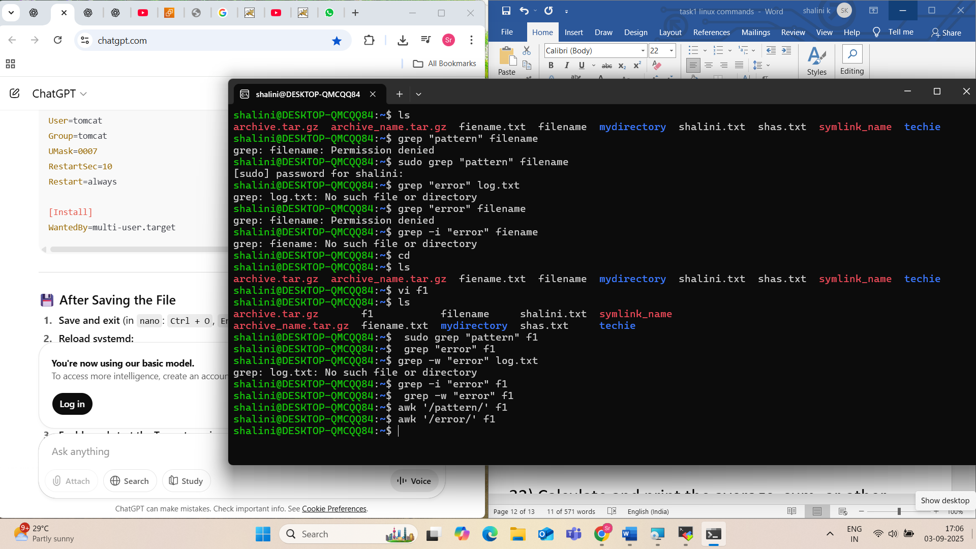

32) Calculate and print the average, sum, or other statistics of a column.  
33 sales = df['Sales']

34) Count the occurrences of a specific pattern in a file.

35) Sort lines based on a specific field or column.

Create a file(data.txt)

Cat > data.txt

Write content “Alice 34

Bob 28

Charlie 45

David 30”

Now sort it: sort -k2 -n data.txt

-k2 → Sort by column 2

-n → Treat as numbers

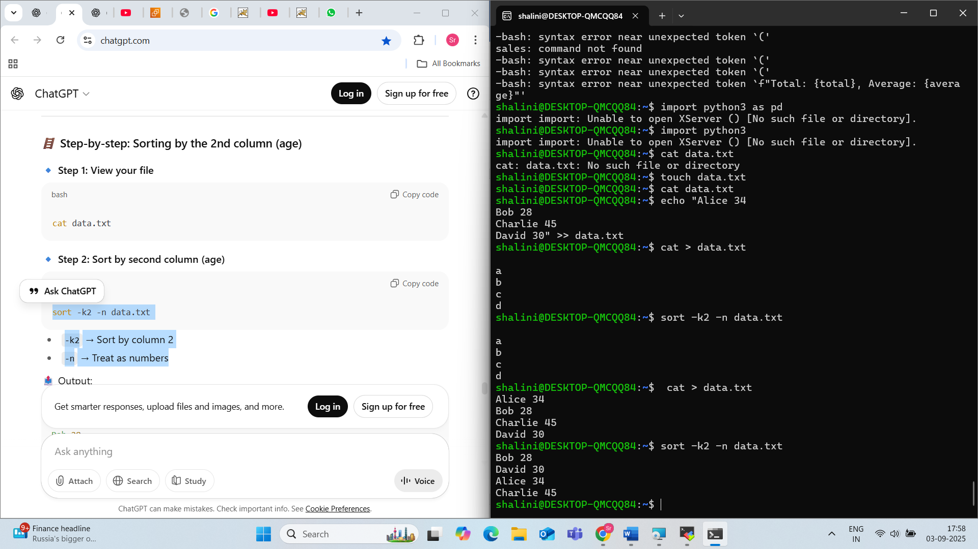

36) Merge multiple files based on a common field or column.

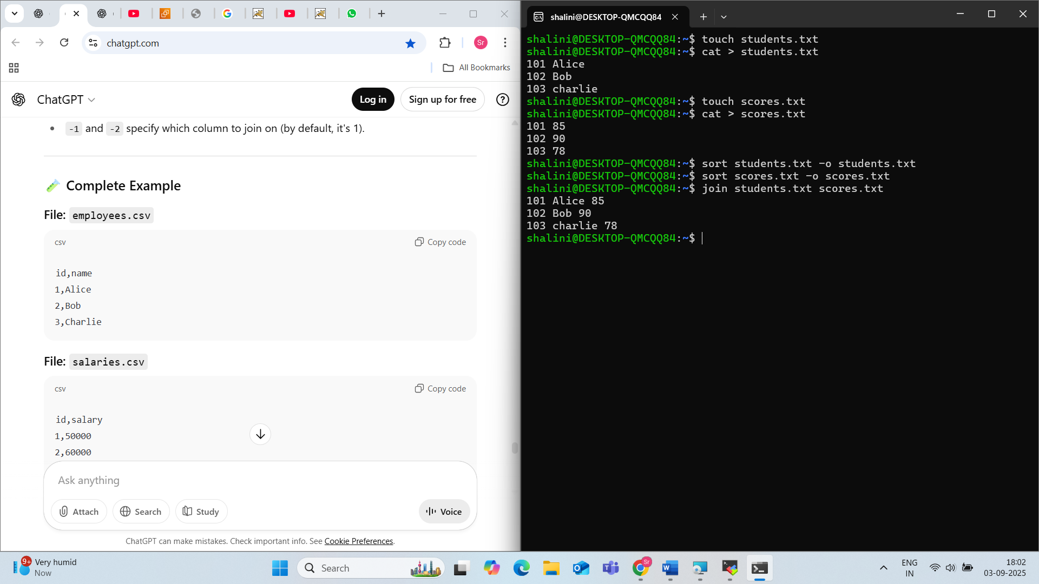

37) Substitute text in a file using search and replace.

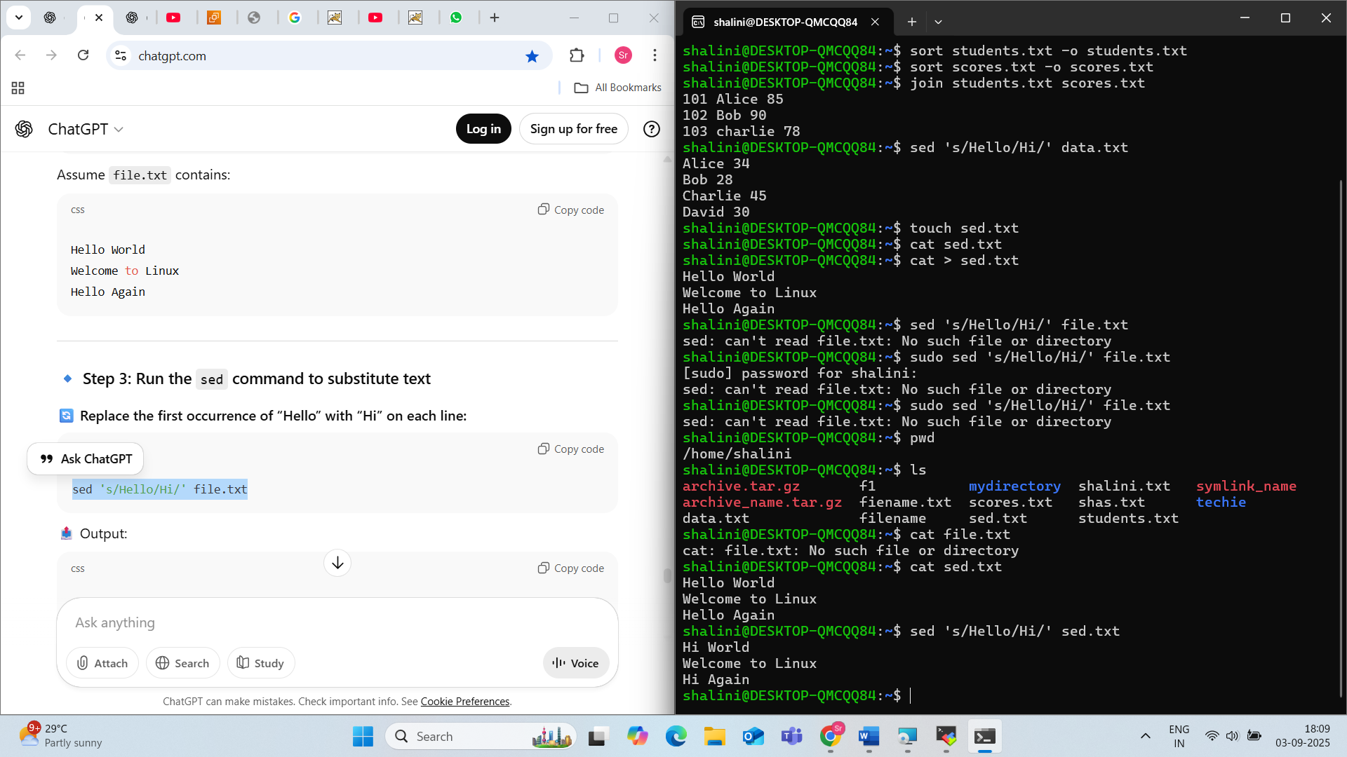

38) Delete specific lines based on a pattern or line number.

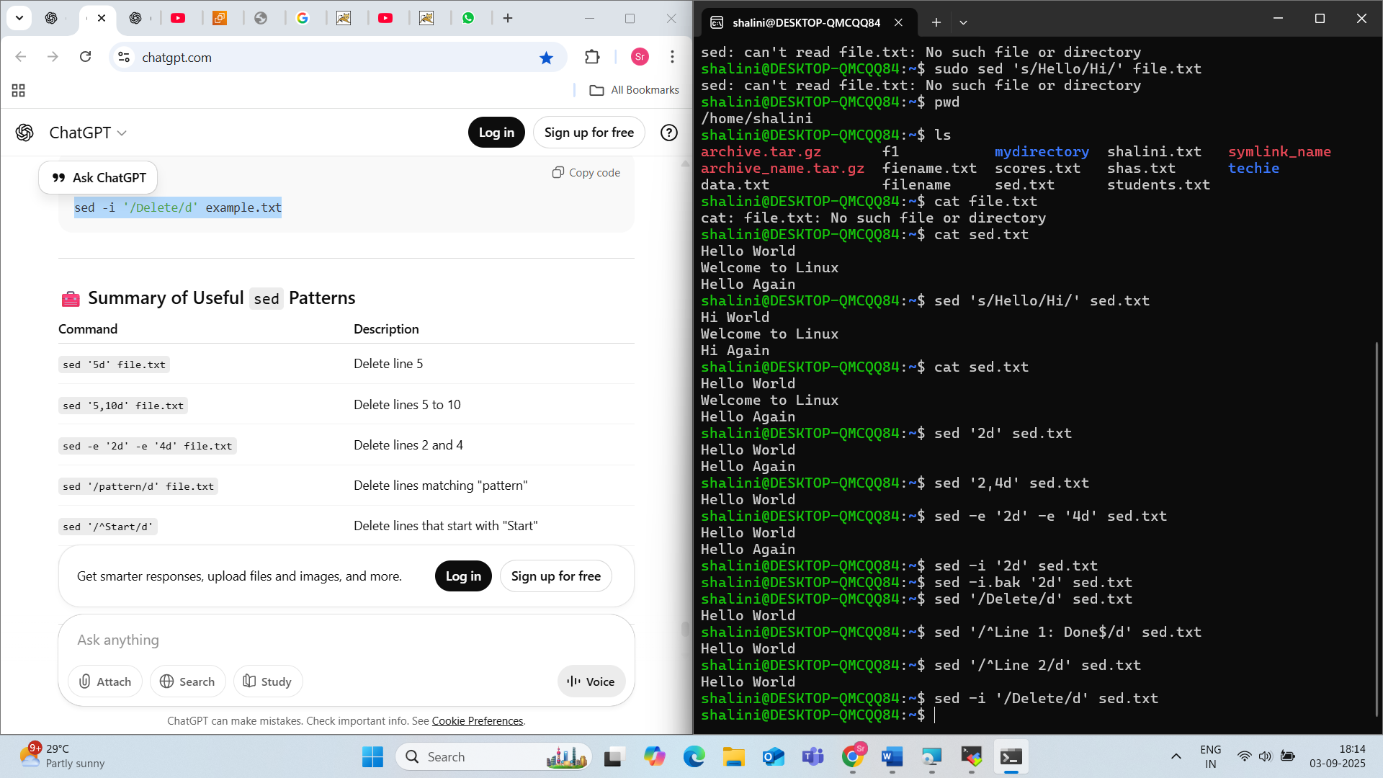

39) Append or insert text before or after a specific pattern or line.

40) sales = df['Sales']  
41 ) Copy file from linux to windows machine

Method 1: Using WinSCP (GUI tool – Easy for beginners)

Method 2: Using SCP from Linux to Windows with OpenSSH Server on Windows

Method 3: Using Samba Shared Folder (Windows Shared Folder)

Method 4: Using FileZilla (Cross-platform GUI)

Method 5: USB Drive (Offline Method)

42)  5 use cases for AWK and 5 use cases for sed

| **Tool** | **Best For** |
| --- | --- |
| awk | Working with **columns/fields** |
| sed | Working with **lines and patterns** |

**AWK** Use Cases (Field-Based Processing)

Print a specific column

awk '{print $2}' file.txt;( Useful for: Extracting usernames, IPs, or values from logs or CSVs)

**2. 🧮 Calculate the sum of a column**

**Goal**: Sum values in column 2

awk '{sum += $2} END {print "Total:", sum}' file.txt

🧠 Useful for: Summing salaries, sales, numbers in reports, etc.

**3. 📏 Print lines based on a condition**

**Goal**: Show lines where the value in column 3 is greater than 100

awk '$3 > 100' file.txt

🧠 Useful for: Filtering rows with high usage, errors, etc.

**4. 🔢 Number all output lines**

awk '{print NR, $0}' file.txt

* NR: built-in AWK variable for line number

🧠 Useful for: Debugging, tracking line positions

**5. 🔧 Format output like a report**

awk '{printf "User: %-10s | Score: %3d\n", $1, $2}' file.txt

🧠 Useful for: Clean, tabular outputs in reports

**🔷 5 SED Use Cases (Pattern-Based Editing)**

**1. 🔄 Find and replace text (basic)**

**Goal**: Replace "foo" with "bar" in a file

sed 's/foo/bar/' file.txt

🧠 Replaces first match per line.

**2. 🌍 Replace all matches on each line**

sed 's/foo/bar/g' file.txt

* g = global (replace all on the line)

🧠 Useful for mass search/replace

**3. ❌ Delete lines matching a pattern**

**Goal**: Delete lines containing "DEBUG"

sed '/DEBUG/d' file.txt

🧠 Useful for cleaning logs or temp files

**4. 🔢 Delete specific line(s) by number**

**Goal**: Delete line 5

sed '5d' file.txt

🧠 Or range: 5,10d — delete lines 5 through 10

**5. 🔁 Insert or append lines**

**Insert before line 3:**

sed '3i\This is a new line' file.txt

**Append after line 3:**

sed '3a\Add this line below' file.txt

🧠 Useful for injecting content into scripts or configs

**✅ Summary Table**

| **Task** | **Use awk** | **Use sed** |
| --- | --- | --- |
| Work with specific columns | ✅ | ❌ |
| Filter lines based on conditions | ✅ | ✅ (basic) |
| Replace text (find and replace) | ❌ | ✅ |
| Delete or modify specific lines | ❌ | ✅ |
| Generate reports or formatted output | ✅ | ❌ |

You can **combine awk and sed** in shell pipelines for powerful text processing.

Example:

cat log.txt | sed '/ERROR/d' | awk '{print $1, $5}'

* Removes error lines
* Prints the 1st and 5th column of remaining lines